**A Blockchain Based System for Safe Food Supply & Supervision**

**INTRODUCTION:**

Technological advances in the supply chain have led people to get all kinds of food products from across the globe. However, the biggest challenge facing the food and beverage industry is to prevent contamination and deterioration of quality when food is being transported within the supply chain, to minimize food fraud or adulteration, and to maintain a low production and operational cost. Food adulteration or food fraud is one of the major factors that affect the food industry on a larger scale. It is reported that most high valued food products are replaced with cheaper constituents under the same label as it happened in Europe in the year of 2013, where products labelled as beef were found to be containing 80–90% of horse meat, in which the food supplier had failed to report the issue to the local governing authorities. Though this incident of contamination did not lead to any public health issue, there were potential health-related risks because of the chemicals being used for processing the meat. Contrarily, research conducted by the Food and Drug Administration Authority (FDA) lead to the discovery of supposititious chemicals and contamination of honey from China. It was found that unapproved agricultural chemicals and unnatural compounds and antibiotics were found in the honey. The World Health Organization (WHO) report says that nearly 3.2 million children and infants die annually due to food contamination issues. Contamination generally occurs during the transportation of food products across the globe. Several organizations are involved in food production, packaging, and transportation of food items to end consumers; which is an extremely enormous and tedious task to trace back the exact point of contamination. The centre for disease control articulates the fact that “more than 48 million Americans” are affected each year due to food contamination. Food product poisoning or contamination will bring devastating effects on the supply chain industry. Since the food supply chain is a multi-stage platform with numerous actors such as farmers or producers, processing centres, distributors, suppliers, retailers, and consumers, there is a high chance of the food product being contaminated during the transportation of food products either accidentally or deliberately. The level of risk faced is almost the same for the production and transportation of frozen and fresh food across the globe. Another major risk in transporting food products is the maintenance of a certain temperature level while being in the supply chain. The study shows that, in May 2013, there was an outbreak of hepatitis A virus infection in the USA and in some of the European countries in which the cause of the outbreak was found to be the frozen berries and pomegranates transported from Turkey and few Gulf nations such as Morocco. Results were analysed considering the shelf-life of berries, transportation failures in terms of temperature maintenance, and the virus’s resistance towards environmental factors such as freezing. Most food manufacturing companies are now focusing on organic food production due to increasing demand dynamics. The companies are concentrating more on the concept of “farm-to-fork” to deliver high quality, fresh organic produce to consumers, which includes fresh vegetables, fruits, dairy products to meat, and poultry products. Though the manufacturers claim that their products are completely organic, and follows the brand’s aim of “farm to fork”, there is no way for an end consumer to track the origin of the product, trace back the food processing centre’s details, hygiene standards maintained by the food distributor, or any details to be sure of the legitimacy of the product that he/she receives due to lack of transparency in the supply chain network. Estévez claims that poultry products are vulnerable to “oxidative damage” which leads to biological damage of muscle lipids leading to the deterioration of poultry meat and the inception of viral infections in chicken; when consumed may lead to adverse effects in humans such as influenza-h5n1 infection. Meatscience.org specifies the fact that before transporting, the poultry meat must be stored at a temperature below 4 °C and it is a huge challenge to maintain proper regelation temperatures during storage and transportation. There is a high chance of contamination and deterioration of poultry products as the distributor may fail to maintain a safe temperature in the container during transit, which when consumed leads to adverse effects and pandemic outbreaks. Despite the presence of considerable and robust food safety standards, the disastrous effects of contaminated food and epidemic outbreaks that follow contamination still exist in the food supply chain sector. The food supply chain network is complex due to its multi-tiered structure, spanning across the globe with multiple participants making it tough to monitor and control food safety-related concerns.

**1.1 Objective of the project:**

The global food supply chain industry has embraced digitalization and has changed consumer’s day-to-day lives in many aspects. Efficient tracking of food products when within the supply chain ensures the safety of the end consumers. However, today’s food supply chain industry falls short of providing dependable tracing of food products due to a lack of visibility and transparency in tracking the food production, processing, distribution, transportation, and movement when with the supply chain, which poses a serious threat to the quality of processed food and the safety of consumers. In this paper, we propose a blockchain and IoT-based framework to regulate and monitor the processed poultry food supply chain industry’s functioning and improves the safety and quality of food products delivered to end-consumer. Our proposed solution utilizes Ethereum smart contracts to develop a transparent, reliable, and tamper-proof food supply chain framework, and ensure the integrity of supply chain transactions by eliminating a central authority. The smart contract regulates and monitors the transactions between the entities in the network and keeps all of the parties, within the network, well informed about transactions. This proposed aims to identify and eliminate food adulteration and contamination; enhance quality and safety in the food industry’s supply chain, improve the transparency of transactions, and legal culpability, which ultimately has a positive impact on consumer trust and the overall brand value.

**2. LITERATURE SURVEY:**

**“Food traceability on blockchain: Walmart’s pork and mango pilots with IBM”,**

**Kamath R (2018)**

In response to food contamination scandals worldwide, retail giant Walmart is tackling food safety in the supply chain using blockchain technology. In 2016, it established the Walmart Food Safety Collaboration Centre in Beijing and plans to invest $25 million over five years to research global food safety (Yianna’s and Liu, 2017). Using IBM’s blockchain solution based on Hyperledger Fabric, Walmart has successfully completed two blockchain pilots: pork in China and mangoes in the Americas (IBM, 2017). With a farm-to-table approach, Walmart’s blockchain solution reduced time for tracking mango origins from seven days to 2.2 seconds and promoted greater transparency across Walmart’s food supply chain (Yianna’s, 2017). IBM called it “complete end-to-end traceability” (McDermott, 2017). The case highlights the challenges of implementing blockchain technology in the food supply chain and the opportunities for deploying blockchain solutions throughout the global food ecosystem to increase safety and reduce waste.

**“Food safety issues in fresh produce: bacterial pathogens, viruses and pesticide residues indicated as major concerns by stakeholders in the fresh produce chain”,**

**Yiqian Chen, Hanxi Deng, (2020)**

a workshop was organized by the EU FP7 Veg-i-Trade project to capture opinions of stakeholders on food safety issues in the global fresh produce supply chain. Food safety experts from various stakeholder types in the farm-to-fork chain were represented: farmer related organizations (n = 6), fresh produce processing and trading companies (n = 17), retail (n = 3), consumer organizations (n = 2), competent authorities (n = 7) and lastly research institutes and universities (n = 19). The experts who originated mainly from European countries (92.6%) were grouped in nine discussion groups per type of stakeholder and asked to rank food safety issues via a scoring approach according to perceived importance from their stakeholder type point of view. Also, information sources for opinion making, appropriate food safety control measures and perceived contextual factors increasingly challenging governance of food safety in fresh produce were ranked according to perceived importance. Although some differences were noted between opinions of the different stakeholders, there was in general an agreement on the main priorities in food safety of fresh produce. Bacterial pathogens were overall considered to be the most important food safety issue for fresh produce, followed by foodborne viruses, pesticide residues and mycotoxins. Alert systems such as the European Commission’s Rapid Alert System for Food and Feed (RASFF) were considered as the most important source of information of food safety issues, followed by reports of international organizations (e.g. WHO, EFSA), legislative documents (e.g. EU legislation), national reports (e.g. on monitoring hazards, foodborne outbreaks) and exchange of information between people (informal contacts). Concerning the control measures, the application of good agricultural practices (GAP) was identified to be the most important control measure to assure the safety of fresh produce, followed by the application of good hygienic practices (GHP) and the certification of food safety management systems (FSMS). Increasing international trade and globalization were overall expected to have a large impact on food safety in fresh produce. Other contextual factors perceived to be important were the food safety policies by governments and the (lack of) food safety knowledge by consumers and other stakeholders of the fresh produce supply chain. Although the various stakeholder groups may conceive issues differently from their proper position in the fresh produce supply chain, no deep disagreements emerged. This type of workshop enhances interaction and risk communication between stakeholders and contributes to a better understanding of each other’s concerns, constraints and interests to deal with the food safety of the increasingly complex and globalized fresh produce supply chain.

**“Food safety traceability system based on blockchain and EPCIS”**

**Lin Q, Wang H, Pei X, Wang J (2019)**

In recent years, food safety issues have drawn growing concerns from society. In order to efficiently detect and prevent food safety problems and trace the accountability, building a reliable traceability system is indispensable. It is especially essential to accurately record, share, and trace the specific data within the whole food supply chain, including the process of production, processing, warehousing, transportation, and retail. The traditional traceability systems have issues, such as data invisibility, tampering, and sensitive information disclosure. The blockchain is a promising technology for the food safety traceability system because of the characteristics, such as the irreversible time vector, smart contract, and consensus algorithm. This paper proposes a food safety traceability system based on the blockchain and the EPC Information Services and develops a prototype system. The management architecture of on-chain & off-chain data is proposed as well, through which the traceability system can alleviate the data explosion issue of the blockchain for the Internet of Things. Furthermore, the enterprise-level smart contract is designed to prevent data tampering and sensitive information disclosure during information interaction among participants. The prototype system was implemented based on the Ethereum. According to the test results, the average time of information query response is around 2 Ms, while the amount of on-chain data and query counts are 1 GB and 1000 times/s, respectively.

**“A new era of food transparency powered by blockchain. Innov Technol Gov Global,”**

**Yiannas F (2018)**

Modern agri-food supply chains have transitioned from autonomous and independent local actors to globally interlinked system of multifactor connected by complex relationships, affecting ways in which food is produced, processed, transported, and delivered to end consumers. Frequent incidences of fraudulent practices expose lack of transparency in agri-food supply chains, causing concerns related to economic losses, eroding consumer trust and enterprise brand value. Traditionally associated with cryptocurrencies, banking and finance, blockchains are now being applied in the agri-food sector to address supply chain-related challenges. This article examines the question: How blockchain technology facilitates transparency in agri-food supply chains? Primary attributes of blockchain, namely traceability, immutability, auditability, and provenance, promote transparency in supply chains. Using thematic analysis, the following three areas were identified for implementing blockchain in agri-food supply chains: first, agri-food distribution; second, agri-food origin and sourcing; third, agri-food safety and quality. By cross-mapping thematic areas with primary attributes, our analysis resulted in classification of 25 uses cases. Preliminary findings of this study highlight blockchain-enabled transparency via contemporary uses cases in conceptual, proof-of-concept and commercial stages. It is imperative to sift through the hype and scrutinize limitations of the technology which could interfere with its adoption, deployment, and scalability in agri-food supply chains.

**“Economically motivated adulteration (EMA) of food: common characteristics of EMA incidents”,**

**Everstine K, Spink J, Kennedy S (2013)**

Economically motivated adulteration (EMA) of food, also known as food fraud, is the intentional adulteration of food for financial advantage. A common form of EMA, undeclared substitution with alternative ingredients, is usually a health concern because of allergen labelling requirements. As demonstrated by the nearly 300,000 illnesses in China from melamine adulteration of infant formula, EMA also has the potential to result in serious public health consequences. Furthermore, EMA incidents reveal gaps in quality assurance testing methodologies that could be exploited for intentional harm. In contrast to foodborne disease outbreaks, EMA incidents present a particular challenge to the food industry and regulators because they are deliberate acts that are intended to evade detection. Large-scale EMA incidents have been described in the scientific literature, but smaller incidents have been documented only in media sources. We reviewed journal articles and media reports of EMA since 1980. We identified 137 unique incidents in 11 food categories: fish and seafood (24 incidents), dairy products (15), fruit juices (12), oils and fats (12), grain products (11), honey and other natural sweeteners (10), spices and extracts (8), wine and other alcoholic beverages (7), infant formula (5), plant-based proteins (5), and other food products (28). We identified common characteristics among the incidents that may help us better evaluate and reduce the risk of EMA. These characteristics reflect the ways in which existing regulatory systems or testing methodologies were inadequate for detecting EMA and how novel detection methods and other deterrence strategies can be deployed. Prevention and detection of EMA cannot depend on traditional food safety strategies. Comprehensive food protection, as outlined by the Food Safety Modernization Act, will require innovative methods for detecting EMA and for targeting crucial resources toward the riskiest food products.

**“F.D.A. says livestock were fed pet food with suspect chemical,”**

**Abruzzese. S (2007)**

The FDA is dedicated to taking all steps possible to help pet owners have confidence that the food they buy for their animal companions is safe and wholesome. We are issuing this corporate-wide warning letter because inspections of Midwestern Pet Foods, Inc.’s manufacturing plants revealed evidence of violations, which were shared across multiple plants and were associated with the illness or death of hundreds of pets who had eaten the company’s dry dog food. Samples of dog food were found to contain high levels of aflatoxin. It is imperative that manufacturers and distributors of pet foods understand their responsibility to comply with all requirements of federal law and FDA regulations and, when applicable, to implement a robust hazard analysis and risk-based preventive controls program. We’ll continue to hold companies accountable and protect animal health as a core element of the FDA’s public health mission.

**“Identifying supply chain value using RFID-enabled distributed decision-making for food quality and assurance,”**

**Butcher T, Grant DB (2012)**

This chapter conceptually considers how retailers might integrate radio frequency identification (RFID) technology and distributed decision making (DDM) to provide real-time product information visibility to enhance food retail supply chain decision-making for assurance of quality and safety. A pilot research project in one UK retailer’s fresh meat supply chain is used to illustrate these concepts. Value stream mapping (VSM) and on-site interviews were the primary research methods for the project. A current state VSM found non-value adding activities in time and labour processes, which in turn led to increased errors. A future state VSM suggests that RFID technology would increase information visibility, reduce handling and checking, and increase speed when it is integrated with an appropriate DDM system. There are potentially large savings to be had by implementing RFID and DDM systems where information is required for traceability and control of food quality and safety.

**“Contaminated food: a major cause of diarrhea and associated malnutrition among infants and young children,”**

**World Health Organization (1993)**

Infections and the malnutrition associated with them are responsible for a significant proportion of the 13 million deaths among infants and children under 5 years of age worldwide each year. After respiratory infections, diarrhoeal diseases are the commonest illnesses and have the greatest negative impact upon the growth of infants and young children. The causes of diarrhoeal diseases have traditionally been ascribed to water supply and sanitation. In attempts to prevent such diseases, efforts by governments and nongovernmental organizations have been focused on and sometimes limited to improving water supply and sanitation as well as promoting and protecting breast-feeding. Based on studies reported in the literature, this review article demonstrates that weaning foods prepared under unhygienic conditions are frequently heavily contaminated with pathogens and thus are a major factor in the cause of diarrhoeal diseases and associated malnutrition. In the light of the evidence presented, it appears that current efforts are not sufficient to prevent diarrhoeal diseases: education of mothers in food safety principles, particularly weaning food, must also receive high priority. Educational programmes based on the hazard-analysis-critical-control-point approach, taking into consideration also sociocultural factors, should be integrated into all national infant feeding or food and nutrition programmes.

**“Product contamination in a multi-stage food supply chain,”**

**Chebolu-Subramanian V, Gaukler GM (2015)**

Food product contamination has potentially devastating effects on companies and supply chains. However, the impact of contamination has still not been thoroughly studied from a supply chain planning perspective. This paper models a contamination event in a generic food supply chain consisting of suppliers, processing centres, and retailers. Contamination is detected through either company or government agency sampling tests or through reports of a food borne illness. In this research, we analyse the impact of origin and choice of sampling strategies, and product and supply chain attributes on a contamination event. We also simulate a real-world tomato contamination case to gain further insights.

**“Poultry and poultry products-risks for human health. Food and Agriculture Organization of the United Nations,”**

**da Silva MV (2013)**

This scoping review was conducted to systematically search and chronicle scientific literature pertinent to poultry intake and human health. The protocol (uploaded to Open Science Framework, https://osf.io/2k7bj/) was conducted in accordance with Preferred Reporting Items for Systematic Reviews and Meta-Analyses extension for scoping reviews guidelines. Articles with observational and experimental research, narrative and systematic reviews, and meta-analyses were included. Among 13,141 articles identified, 525 met inclusion criteria. Among these 525 articles, 212 focused on cancer morbidity and mortality; 41 on cardiovascular disease (CVD) morbidity and mortality; 52 on CVD risk factors; 32 on type 2 diabetes mellitus (T2DM) morbidity and mortality; 33 on T2DM risk factors; and 42 on body weight and body composition. An “Other” category (181 articles) included nutrient status, psychological well-being/mental health, cognition, microbiome, chronic kidney disease, non-alcoholic fatty liver disease, skin disorders, and fertility, among others. Among the 525 included articles, 366 were observational, 64 were experimental, and 76 were reviews and meta-analyses. Eighty-three percent of articles focused on adults or older adults. A paucity of research exists to support poultry as health-promoting foods, with most research only indirectly assessing poultry intake compared with other foods of interest (e.g., red meats or plant-based protein foods). No randomized controlled trials and only 1% of OBS assessed the influence of processed poultry intake on human health. In the future, the relative health effects of consuming poultry will be compared with a widening array of traditional and new protein-rich food products, necessitating the need for research to assess poultry as foods of choice. Science and health professionals, the poultry industry, and the public will benefit from new observational and experimental research to address cutting-edge scientific, public policy, and consumer topics pertinent to poultry intake and human health.

**3. SYSTEM ANALYSIS**

**3.1 Existing System**

The current food supply management system relies on a centralized server, where all product details are stored. This centralized approach is vulnerable to manipulation by corrupt employees who can alter product details or expiry dates for bribes. Fake products can also be registered, leading to customer dissatisfaction and health risks. Additionally, there is no tool to detect such tampering or unauthorized changes in the database. If the server is hacked, all data could be lost, as the system depends entirely on a single server. These flaws harm public trust, reduce business revenue, and hinder national growth.

**Disadvantages**

1. Centralized Server Vulnerability
2. Data Manipulation
3. No Tamper Detection
4. Hacking Risks
5. Customer Dissatisfaction
6. Reduced Trust
7. Impact on Business Revenue

**3.2 PROPOSED SYSTEM**

The proposed system uses blockchain technology to manage food supply chain data. Blockchain stores information in a decentralized manner across multiple nodes, ensuring data availability even if one node fails. It secures data through encryption and links each record using a unique hash code, making it tamper-proof. Changes in data are impossible without altering the entire chain, ensuring the authenticity of records. This decentralized setup prevents manipulation and eliminates reliance on a single server, making the system more secure and reliable.

**Advantages**

1. Decentralized Architecture
2. Tamper-Proof Records
3. Enhanced Security
4. Transparency
5. Smart Contracts
6. Reliability
7. Detection of Fake Products
8. Boost to Business and National Growth

**Modules:**

In propose work to manage supply chain data we have designed following modules

1. Admin: admin can login to system by using username and password as ‘admin’ and ‘admin’. After login admin will add details of all supply chains partners (stakeholders) and give login details to each partner. This partner can be raw material suppliers or farmers, Manufacturer, Retailers and Distributors. Admin will generate orders for required supply and can run ML algorithms to predict or forecast demand of particular product in future. Admin can view details of all available partners and can view all tracing details of product processing in the map.
2. Stakeholder Raw Material Supplier login: Raw material supplier will receive order from admin and then forward all raw materials to ‘MANUFACTURER’ and all this trace details will be updated in Blockchain.
3. Manufacturer Login: can login to system and receive raw material and can manufacture product and supply to distributor
4. Distributor Login: can login to system and can distribute product to Retailer
5. Retailer Login: can login to system and then sale product to N consumer
6. Consumer or any government official: by using product ID can trace all details of the product.

Recommendation: any consumer can run this module to get recommendation of particular purchase items. If he purchases beef then he will enter BEEF and system will recommend ‘Chicken’ as he may purchase chicken also.

**3.3. PROCESS MODEL USED WITH JUSTIFICATION**

**SDLC (Umbrella Model):**

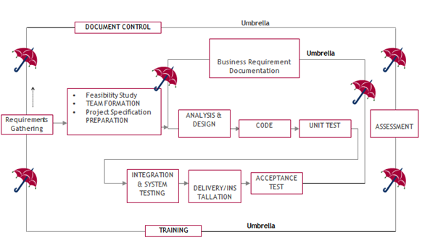

SDLC is nothing but Software Development Life Cycle. It is a standard which is used by software industry to develop good software.

**Stages in SDLC:**

* Requirement Gathering
* Analysis
* Designing
* Coding
* Testing
* Maintenance

**Requirements Gathering stage:**

The requirements gathering process takes as its input the goals identified in the high-level requirements section of the project plan. Each goal will be refined into a set of one or more requirements. These requirements define the major functions of the intended application, define operational data areas and reference data areas, and define the initial data entities. Major functions include critical processes to be managed, as well as mission critical inputs, outputs and reports. A user class hierarchy is developed and associated with these major functions, data areas, and data entities. Each of these definitions is termed a Requirement. Requirements are identified by unique requirement identifiers and, at minimum, contain a requirement title and textual description.

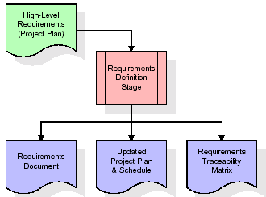

These requirements are fully described in the primary deliverables for this stage: the Requirements Document and the Requirements Traceability Matrix (RTM). The requirements document contains complete descriptions of each requirement, including diagrams and references to external documents as necessary. Note that detailed listings of database tables and fields are *not* included in the requirements document.

The title of each requirement is also placed into the first version of the RTM, along with the title of each goal from the project plan. The purpose of the RTM is to show that the product components developed during each stage of the software development lifecycle are formally connected to the components developed in prior stages.

In the requirements stage, the RTM consists of a list of high-level requirements, or goals, by title, with a listing of associated requirements for each goal, listed by requirement title. In this hierarchical listing, the RTM shows that each requirement developed during this stage is formally linked to a specific product goal. In this format, each requirement can be traced to a specific product goal, hence the term requirements traceability.

The outputs of the requirements definition stage include the requirements document, the RTM, and an updated project plan.

* Feasibility study is all about identification of problems in a project.
* No. of staff required to handle a project is represented as Team Formation, in this case only modules are individual tasks will be assigned to employees who are working for that project.
* Project Specifications are all about representing of various possible inputs submitting to the server and corresponding outputs along with reports maintained by administrator.

**Analysis Stage:**

The planning stage establishes a bird's eye view of the intended software product, and uses this to establish the basic project structure, evaluate feasibility and risks associated with the project, and describe appropriate management and technical approaches.

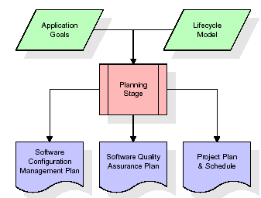

The most critical section of the project plan is a listing of high-level product requirements, also referred to as goals. All of the software product requirements to be developed during the requirements definition stage flow from one or more of these goals. The minimum information for each goal consists of a title and textual description, although additional information and references to external documents may be included. The outputs of the project planning stage are the configuration management plan, the quality assurance plan, and the project plan and schedule, with a detailed listing of scheduled activities for the upcoming Requirements stage, and high-level estimates of effort for the out stages.

**Designing Stage:**

The design stage takes as its initial input the requirements identified in the approved requirements document. For each requirement, a set of one or more design elements will be produced as a result of interviews, workshops, and/or prototype efforts. Design elements describe the desired software features in detail, and generally include functional hierarchy diagrams, screen layout diagrams, tables of business rules, business process diagrams, pseudo code, and a complete entity-relationship diagram with a full data dictionary. These design elements are intended to describe the software in sufficient detail that skilled programmers may develop the software with minimal additional input.

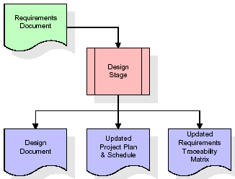  
When the design document is finalized and accepted, the RTM is updated to show that each design element is formally associated with a specific requirement. The outputs of the design stage are the design document, an updated RTM, and an updated project plan.

**Development (Coding) Stage:**

The development stage takes as its primary input the design elements described in the approved design document. For each design element, a set of one or more software artifacts will be produced. Software artifacts include but are not limited to menus, dialogs, and data management forms, data reporting formats, and specialized procedures and functions. Appropriate test cases will be developed for each set of functionally related software artifacts, and an online help system will be developed to guide users in their interactions with the software.

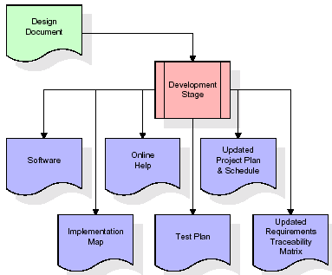

The RTM will be updated to show that each developed artifact is linked to a specific design element, and that each developed artifact has one or more corresponding test case items. At this point, the RTM is in its final configuration. The outputs of the development stage include a fully functional set of software that satisfies the requirements and design elements previously documented, an online help system that describes the operation of the software, an implementation map that identifies the primary code entry points for all major system functions, a test plan that describes the test cases to be used to validate the correctness and completeness of the software, an updated RTM, and an updated project plan.

**Integration & Test Stage:**

During the integration and test stage, the software artifacts, online help, and test data are migrated from the development environment to a separate test environment. At this point, all test cases are run to verify the correctness and completeness of the software. Successful execution of the test suite confirms a robust and complete migration capability. During this stage, reference data is finalized for production use and production users are identified and linked to their appropriate roles. The final reference data (or links to reference data source files) and production user list are compiled into the Production Initiation Plan.

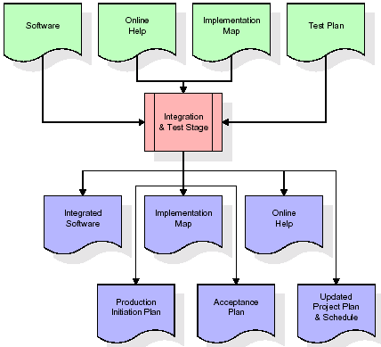

The outputs of the integration and test stage include an integrated set of software, an online help system, an implementation map, a production initiation plan that describes reference data and production users, an acceptance plan which contains the final suite of test cases, and an updated project plan.

* **Installation & Acceptance Test:**

During the installation and acceptance stage, the software artifacts, online help, and initial production data are loaded onto the production server. At this point, all test cases are run to verify the correctness and completeness of the software. Successful execution of the test suite is a prerequisite to acceptance of the software by the customer.

After customer personnel have verified that the initial production data load is correct and the test suite has been executed with satisfactory results, the customer formally accepts the delivery of the software.

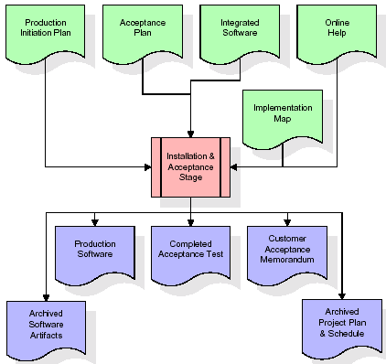

The primary outputs of the installation and acceptance stage include a production application, a completed acceptance test suite, and a memorandum of customer acceptance of the software. Finally, the PDR enters the last of the actual labor data into the project schedule and locks the project as a permanent project record. At this point the PDR "locks" the project by archiving all software items, the implementation map, the source code, and the documentation for future reference.

**Maintenance:**

Outer rectangle represents maintenance of a project, Maintenance team will start with requirement study, understanding of documentation later employees will be assigned work and they will undergo training on that particular assigned category. For this life cycle there is no end, it will be continued so on like an umbrella (no ending point to umbrella sticks).

**3.4. Software Requirement Specification**

**3.4.1. Overall Description**

A Software Requirements Specification (SRS) – a requirements specification for a software system is a complete description of the behaviour of a system to be developed. It includes a set of use cases that describe all the interactions the users will have with the software. In addition to use cases, the SRS also contains non-functional requirements. Non-functional requirements are requirements which impose constraints on the design or implementation (such as performance engineering requirements, quality standards, or design constraints).

System requirements specification: A structured collection of information that embodies the requirements of a system. A business analyst, sometimes titled system analyst, is responsible for analysing the business needs of their clients and stakeholders to help identify business problems and propose solutions. Within the systems development lifecycle domain, the BA typically performs a liaison function between the business side of an enterprise and the information technology department or external service providers. Projects are subject to three sorts of requirements:

* Business requirements describe in business terms what must be delivered or accomplished to provide value.
* Product requirements describe properties of a system or product (which could be one of several ways to accomplish a set of business requirements.)
* Process requirements describe activities performed by the developing organization. For instance, process requirements could specify. Preliminary investigation examines project feasibility, the likelihood the system will be useful to the organization. The main objective of the feasibility study is to test the Technical, Operational and Economical feasibility for adding new modules and debugging old running system. All system is feasible if they are unlimited resources and infinite time. There are aspects in the feasibility study portion of the preliminary investigation:
* **ECONOMIC FEASIBILITY**

A system can be developed technically and that will be used if installed must still be a good investment for the organization. In the economic feasibility, the development cost in creating the system is evaluated against the ultimate benefit derived from the new systems. Financial benefits must equal or exceed the costs. The system is economically feasible. It does not require any addition hardware or software. Since the interface for this system is developed using the existing resources and technologies available at NIC, there is nominal expenditure and economical feasibility for certain.

* **Operational Feasibility**

Proposed projects are beneficial only if they can be turned out into information system. That will meet the organization’s operating requirements. Operational feasibility aspects of the project are to be taken as an important part of the project implementation. This system is targeted to be in accordance with the above-mentioned issues. Beforehand, the management issues and user requirements have been taken into consideration. So there is no question of resistance from the users that can undermine the possible application benefits. The well-planned design would ensure the optimal utilization of the computer resources and would help in the improvement of performance status.

* **TECHNICAL FEASIBILITY**

Earlier no system existed to cater to the needs of ‘Secure Infrastructure Implementation System’. The current system developed is technically feasible. It is a web-based user interface for audit workflow at NIC-CSD. Thus, it provides an easy access to. the users. The database’s purpose is to create, establish and maintain a workflow among various entities in order to facilitate all concerned users in their various capacities or roles. Permission to the users would be granted based on the roles specified. Therefore, it provides the technical guarantee of accuracy, reliability and security.

**3.4.2. External Interface Requirements**

**User Interface**

The user interface of this system is a user-friendly python Graphical User Interface.

**Hardware Interfaces**

The interaction between the user and the console is achieved through python capabilities.

**Software Interfaces**

The required software is python.

**SYSTEM REQUIREMENT:**

**HARDWARE REQUIREMENTS:**

# Processor - Intel i3(min)

* Speed - 1.1 GHz
* RAM - 4GB (min)
* Hard Disk - 500 GB

**SOFTWARE REQUIREMENTS:**

* Operating System - Windows10(min)
* Programming Language - Python

**4. SYSTEM DESIGN**

**UML Diagram:**

The Unified Modelling Language allows the software engineer to express an analysis model using the modelling notation that is governed by a set of syntactic semantic and pragmatic rules.

A UML system is represented using five different views that describe the system from distinctly different perspective. Each view is defined by a set of diagrams, which is as follows.

* + **User Model View**
    1. This view represents the system from the user’s perspective.
    2. The analysis representation describes a usage scenario from the end-user’s perspective.
  + **Structural Model view**
    1. In this model the data and functionality are arrived from inside the system.
    2. This model view models the static structures.
* **Behavioural Model View**

It represents the dynamic of behavioural as parts of the system, depicting the interactions of collection between various structural elements described in the user model and structural model view.

* **Implementation Model View**

In this the structural and behavioural as parts of the system are represented as they are to be built.

* **Environmental Model View**

In these the structural and behavioural aspects of the environment in which the system is to be implemented are represented.

**Class Diagram:**

The class diagram is the main building block of object-oriented modeling. It is used both for general conceptual modeling of the systematic of the application, and for detailed modeling translating the models into programming code. Class diagrams can also be used for data modeling. The classes in a class diagram represent both the main objects, interactions in the application and the classes to be programmed. In the diagram, classes are represented with boxes which contain three parts:

* The upper part holds the name of the class
* The middle part contains the attributes of the class
* The bottom part gives the methods or operations the class can take or undertake.



**Use case Diagram:**

A **use case diagram** at its simplest is a representation of a user's interaction with the system and depicting the specifications of a use case. A use case diagram can portray the different types of users of a system and the various ways that they interact with the system. This type of diagram is typically used in conjunction with the textual use case and will often be accompanied by other types of diagrams as well.



**Sequence diagram:**

A sequence diagram is a kind of interaction diagram that shows how processes operate with one another and in what order. It is a construct of a Message Sequence Chart. A sequence diagram shows object interactions arranged in time sequence. It depicts the objects and classes involved in the scenario and the sequence of messages exchanged between the objects needed to carry out the functionality of the scenario. Sequence diagrams are typically associated with use case realizations in the Logical View of the system under development. Sequence diagrams are sometimes called event diagrams, event scenarios, and timing diagrams.



**Collaboration diagram:**

A collaboration diagram describes interactions among objects in terms of sequenced messages. Collaboration diagrams represent a combination of information taken from class, sequence, and use case diagrams describing both the static structure and dynamic behaviour of a system.



**Component Diagram:**

In the Unified Modelling Language, a component diagram depicts how components are wired together to form larger components and or software systems. They are used to illustrate the structure of arbitrarily complex systems.

Components are wired together by using an assembly connector to connect the required interface of one component with the provided interface of another component. This illustrates the service consumer - service provider relationship between the two components.



**Deployment Diagram:**

A **deployment diagram** in the Unified Modeling Language models the *physical* deployment of artifacts on nodes. To describe a web site, for example, a deployment diagram would show what hardware components ("nodes") exist (e.g., a web server, an application server, and a database server), what software components ("artifacts") run on each node (e.g., web application, database), and how the different pieces are connected (e.g. JDBC, REST, RMI).

The nodes appear as boxes, and the artifacts allocated to each node appear as rectangles within the boxes. Nodes may have sub nodes, which appear as nested boxes. A single node in a deployment diagram may conceptually represent multiple physical nodes, such as a cluster of database servers.



**Activity Diagram:**

Activity diagram is another important diagram in UML to describe dynamic aspects of the system. It is basically a flow chart to represent the flow form one activity to another

activity. The activity can be described as an operation of the system. So the control flow is drawn from one operation to another. This flow can be sequential, branched or concurrent

**AdminLogin**

**Stakeholder Raw Material Supplier login**

**Manufacturer Login**

**Distributor Login**

**Retailer Login**

**RunRF**

**Consumer or any government official**

**RunDT**

**Recommendation**

**Data Flow Diagram:**

Data flow diagrams illustrate how data is processed by a system in terms of inputs and outputs. Data flow diagrams can be used to provide a clear representation of any business function. The technique starts with an overall picture of the business and continues by analyzing each of the functional areas of interest. This analysis can be carried out in precisely the level of detail required. The technique exploits a method called top-down expansion to conduct the analysis in a targeted way.

As the name suggests, Data Flow Diagram (DFD) is an illustration that explicates the passage of information in a process. A DFD can be easily drawn using simple symbols. Additionally, complicated processes can be easily automated by creating DFDs using easy-to-use, free downloadable diagramming tools. A DFD is a model for constructing and analyzing information processes. DFD illustrates the flow of information in a process depending upon the inputs and outputs. A DFD can also be referred to as a Process Model. A DFD demonstrates business or technical process with the support of the outside data saved, plus the data flowing from the process to another and the end results.

**User**

1. Admin Login 2. Successfully Admin Login

3. Stakeholder Raw Material 4. Successfully Stakeholder Raw Material

Supplier login Supplier login

5. Manufacturer Login 6. Successfully Manufacturer Login

7. Distributor Login 8. Successfully Distributor Login

9. Retailer Login 10. Successfully Retailer Login

11. RunRF 12. Successfully RunRF

13. RunDT 14. Successfully RunDT

15. Consumer or any government official 16. Successfully Consumer or any government

official

17. Recommendation 18. Successfully Recommendation

**5. IMPLEMETATION**

**5.1 PYTHON**

* One of the most popular languages is Python. Guido van Rossum released this language in 1991. Python is available on the Mac, Windows, and Raspberry Pi operating systems. The syntax of Python is simple and identical to that of English. When compared to Python, it was seen that the other language requires a few extra lines.

*It is an interpreter-based language because code may be run line by line after it has been written. This implies that rapid prototyping is possible across all platforms. Python is a big language with a free, binary-distributed interpreter standard library.

* It is inferior to maintenance that is conducted and is straightforward to learn. It is an object-oriented, interpreted programming language. It supports several different programming paradigms in addition to object-oriented programming, including functional and procedural programming.

* It supports several different programming paradigms in addition to object-oriented programming, including practical and procedural programming. Python is mighty while maintaining a relatively straightforward syntax. Classes, highly dynamic data types, modules, and exceptions are covered. Python can also be utilised by programmes that require programmable interfaces as an external language.

Here are some key features and characteristics of Python:

* Readability: Python emphasizes code readability with its clean and intuitive syntax. It uses indentation and whitespace to structure code blocks, making it easy to understand and maintain.
* Easy to Learn: Python's simplicity and readability make it an excellent choice for beginners. Its straightforward syntax and extensive documentation make it accessible for newcomers to programming.
* Interpreted Language: Python is an interpreted language, meaning that it doesn't need to be compiled before running. The Python interpreter reads and executes the code directly, making the development process faster and more interactive.
* Cross-platform Compatibility: Python is available for major operating systems like Windows, macOS, and Linux. This cross-platform compatibility allows developers to write code once and run it on different platforms without modifications.
* Large Standard Library: Python comes with a vast standard library that provides ready-to-use modules and functions for various tasks. It covers areas such as file I/O, networking, regular expressions, databases, and more, saving developers time and effort.
* Extensible and Modular: Python supports modular programming, enabling developers to organize code into reusable modules and packages. Additionally, Python allows integrating modules written in other languages, such as C or C++, providing flexibility and performance optimizations.
* Wide Range of Libraries and Frameworks: Python has a vibrant ecosystem with numerous third-party libraries and frameworks. These libraries, such as NumPy, pandas, TensorFlow, and Django, extend Python's capabilities for specific domains, making it a powerful tool for diverse applications.
* Object-Oriented: Python supports object-oriented programming (OOP) principles, allowing developers to create and work with classes and objects. OOP provides a structured approach to code organization, promoting code reuse and modularity.
* Dynamic Typing: Python is dynamically typed, meaning variable types are determined at runtime. Developers do not need to declare variable types explicitly, which enhances flexibility and simplifies code writing.

**5.2 Installation**

To install Python on your computer, follow these basic steps:

* Step 1: Visit the Python website Go to the official Python website at <https://www.python.org/>.
* Step 2: Select the operating system Choose the appropriate installer for your operating system. Python supports Windows, macOS, and various Linux distributions. Make sure to select the correct version that matches your operating system.
* Step 3: Check which version of Python is installed; if the 3.7.0 version is not there, uninstall it through the control panel and
* Step 4: Install Python 3.7.0 using Cmd.
* Step 5: Install the all libraries that required to run the project
* Step 6: Run

**5.3 Python Features:**

1. **Easy:** Because Python is a more accessible and straightforward language, Python programming is easier to learn.
2. **Interpreted language:** Python is an interpreted language, therefore it can be used to examine the code line by line and provide results.
3. **Open Source:** Python is a free online programming language since it is open-source.
4. **Portable:** Python is portable because the same code may be used on several computer standard
5. **libraries:** Python offers a sizable library that we may utilize to create applications quickly.
6. **GUI:** It stands for GUI (Graphical User Interface)
7. **Dynamical typed:** Python is a dynamically typed language, therefore the type of the value will be determined at runtime.

**5.4 Python GUI (Tkinter)**

* Python provides a wide range of options for GUI development (Graphical User Interfaces).
* Tkinter, the most widely used GUI technique, is used for all of them.
* The Tk GUI toolkit offered by Python is used with the conventional Python interface.
* Tkinter is the easiest and quickest way to write Python GUI programs.
* Using Tkinter, creating a GUI is simple.
* A part of Python's built-in library is Tkinter. The GUI programs were created.
* Python and Tkinter together give a straightforward and quick way. The Tk GUI toolkit's object-oriented user interface is called Tkinter.

Making a GUI application is easy using Tkinter. Following are the steps:

1) Install the Tkinter module in place.

2) The GUI applicatioMakeske the primary window

3) Include one or more of the widgets mentioned above in the GUI application.

4) Set up the main event loop such that it reacts to each user-initiated event.

Although Tkinter is the only GUI framework included in the Python standard library, Python includes a GUI framework. The default library for Python is called Tkinter. Tk is a scripting language often used in designing, testing, and developing GUIs. Tk is a free, open-source widget toolkit that may be used to build GUI applications in a wide range of computer languages.

**5.5 Python IDLE**

* Python IDLE offers a full-fledged file editor, which gives you the ability to write and execute Python programs from within this program. The built-in file editor also includes several features, like code completion and automatic indentation, that will speed up your coding workflow.
* Guido Van Rossum named Python after the British comedy group Monty Python while the name IDLE was chosen to pay tribute to Eric Idle, who was one of the Monty Python's founding members. IDLE comes bundled with the default implementation of the Python language since the 01.5. 2b1 release
* IDLE is used to execute statements similar to Python Shell. IDLE is used to create, modify, and execute Python code. IDLE provides a fully-featured text editor to write Python scripts and provides features like syntax highlighting, auto-completion, and smart indent.
* IDLE has two modes: interactive and script. We wrote our first program, “Hello, World!” in interactive mode. Interactive mode immediately returns the results of commands you enter into the shell. In script mode, you will write a script and then run it.
* The IDE Python IDLE is a good place to start as it helps you become familiar with the way Python works and understand its syntax. This IDE is good to start programming in Python due to its great debugger, but once you are fluent and start developing projects it is necessary to jump to another, more complete IDE.
* Python IDLE (Integrated Development and Learning Environment) is an interactive development environment included with the Python programming language. It provides a convenient way to write, execute, and debug Python code.

When you install Python, IDLE is typically installed along with it. To open IDLE, you can follow these steps:

* Open the command prompt (Windows) or terminal (macOS/Linux).
* Type "idle" and press Enter. Alternatively, you can specify the version with "idle3" or "idle2" for Python 3 or Python 2, respectively.
* Once IDLE is launched, you will see the Python shell, which is an interactive environment where you can type and execute Python code directly.

Here are some features and functionalities provided by Python IDLE:

* Editor: IDLE includes a text editor where you can write your Python code. It offers syntax highlighting, automatic indentation, and code completion to enhance your coding experience.
* Interactive Shell: The Python shell in IDLE allows you to execute Python code interactively. You can type commands, statements, or function calls directly in the shell, and Python will execute them immediately.
* Debugging: IDLE provides basic debugging capabilities to help you find and fix errors in your code. You can set breakpoints, step through code, inspect variables, and track the program's execution.
* Python Help: IDLE provides access to the Python documentation and built-in help. You can access the help menu to find information about Python modules, functions, classes, and more.
* Script Execution: In addition to the interactive shell, IDLE allows you to run Python scripts stored in files. You can write your code in the editor and execute it as a script to see the output or interact with the program.
* Customization: IDLE can be customized to suit your preferences. You can modify settings related to syntax highlighting, indentation, fonts, and more.
* Python IDLE serves as a beginner-friendly development environment and learning tool. It is suitable for writing small scripts, testing code snippets, experimenting with Python features, and learning the language's basics. However, for more advanced development projects, you may consider using other code editors or integrated development environments (IDEs) that provide additional features and better project management capabilities.

**5.6 Libraries**

In Python, libraries (also referred to as modules or packages) are collections of pre-written code that provide additional functionality and tools to extend the capabilities of the Python language. Libraries contain reusable code that developers can leverage to perform specific tasks without having to write everything from scratch.

Python libraries are designed to solve common problems, such as handling data, performing mathematical operations, interacting with databases, working with files, implementing networking protocols, creating graphical user interfaces (GUIs), and much more. They provide ready-to-use functions, classes, and methods that simplify complex operations and save development time.

**Libraries in Python offer various advantages:**

* Code Reusability:
* Efficiency:
* Collaboration
* Domain-Specific Functionality
* To use a Python library, you need to install it first.

There are some libraries following:

* **Pandas:**

Pandas are a Python computer language library for data analysis and manipulation. It offers a specific operation and data format for handling time series and numerical tables. It differs significantly from the release3-clause of the BSD license. It is a well-liked open-source of opinion that is utilized in machine learning and data analysis.

Pandas are a Python package providing fast, flexible, and expressive data structures designed to make working with “relational” or “labelled” data both easy and intuitive. It aims to be the fundamental high-level building block for doing practical, real-world data analysis in Python. Pandas are a Python library used for working with data sets.

* It has functions for analysing, cleaning, exploring, and manipulating data.
* The name "Pandas" has a reference to both "Panel Data", and "Python Data Analysis" and was created by Wes McKinney in 2008.
* Pandas allow us to analyse big data and make conclusions based on statistical theories.
* Pandas can clean messy data sets, and make them readable and relevant.

Relevant data is very important in data science. Pandas are a Python library for data analysis. Started by Wes McKinney in 2008 out of a need for a powerful and flexible quantitative analysis tool, pandas have grown into one of the most popular Python libraries. It has an extremely active community of contributors. The name is derived from the term "panel data", an econometrics term for data sets that include observations over multiple time periods for the same individuals. Its name is a play on the phrase "Python data analysis" itself.

* **NumPy:**

The NumPy Python library for multi-dimensional, big-scale matrices adds a huge number of high-level mathematical functions. It is possible to modify NumPy by utilizing a Python library. Along with line, algebra, and the Fourier transform operations, it also contains several matrices-related functions.

NumPy can be used to perform a wide variety of mathematical operations on arrays. It adds powerful data structures to Python that guarantee efficient calculations with arrays and matrices and it supplies an enormous library of high-level mathematical functions that operate on these arrays and matrices.

* NumPy is a Python library used for working with arrays.
* It also has functions for working in domain of linear algebra, Fourier transform, and matrices.
* NumPy was created in 2005 by Travis Oliphant. It is an open-source project and you can use it freely.
* NumPy stands for Numerical Python.
* In Python we have lists that serve the purpose of arrays, but they are slow to process.
* NumPy aims to provide an array object that is up to 50x faster than traditional Python lists.
* The array object in NumPy is called ndarray, it provides a lot of supporting functions that make working with ndarray very easy.
* Arrays are very frequently used in data science, where speed and resources are very important.
* **Matplotlib:**

It is a multi-platform, array-based data visualization framework built to interact with the whole SciPy stack. MATLAB is proposed as an open-source alternative. Matplotlib is a Python extension and a cross-platform toolkit for graphical plotting and visualization.

Matplotlib is a popular Python library for creating static, animated, and interactive visualizations. It provides a flexible and comprehensive set of tools for generating plots, charts, histograms, scatter plots, and more. Matplotlib is widely used in various fields, including data analysis, scientific research, and data visualization.

Here are some key features and functionalities of the Matplotlib library:

* Plotting Functions
* Customization Options
* Multiple Interfaces
* Integration with NumPy and pandas
* Subplots and Figures:
* Saving and Exporting
* **Scikit-learn:**

The most stable and practical machine learning library for Python is scikit-learn. Regression, dimensionality reduction, classification, and clustering are just a few of the helpful tools it provides through the Python interface for statistical modeling and machine learning. It is an essential part of the Python machine learning toolbox used by JP Morgan. It is frequently used in various machine learning applications, including classification and predictive analysis.

Scikit-learn (also referred to as sklearn) is a widely used open-source machine learning library for Python. It provides a comprehensive set of tools and algorithms for various machine learning tasks, including classification, regression, clustering, dimensionality reduction, model selection, and pre-processing.

Here are some key features and functionalities of the Scikit-learn library:

* Easy-to-Use Interface:
* Broad Range of Algorithms:
* Data Pre-processing and Feature Engineering:
* Model Evaluation and Validation:
* Integration with NumPy and pandas:
* Robust Documentation and Community Support:
* **Keras:**

* Google's Keras is a cutting-edge deep learning API for creating neural networks. It is created in Python and is designed to simplify the development of neural networks. Additionally, it enables the use of various neural networks for computation. Deep learning models are developed and tested using the free and open-source Python software known as Keras.

Keras is a high-level deep learning library for Python. It is designed to provide a user-friendly and intuitive interface for building and training deep learning models. Keras acts as a front-end API, allowing developers to define and configure neural networks while leveraging the computational backend engines, such as Tensor Flow or Theano.

Here are some key features and functionalities of the Keras library:

* User-Friendly API
* Multi-backend Support
* Wide Range of Neural Network Architectures
* Pre-trained Models and Transfer Learning:
* Easy Model Training and Evaluation:
* GPU Support:
* **h5py:**

* The h5py Python module offers an interface for the binary HDF5 data format. Thanks to p5py, the top can quickly halt the vast amount of numerical data and alter it using the NumPy library. It employs common syntax for Python, NumPy, and dictionary arrays.

h5py is a Python library that provides a simple and efficient interface for working with datasets and files in the Hierarchical Data Format 5 (HDF5) format. HDF5 is a versatile data format commonly used for storing and managing large volumes of numerical data.

Here are some key features and functionalities of the h5py library:

* + HDF5 File Access
  + Dataset Handling:
  + Group Organization:
  + Attributes:
  + Compatibility with NumPy
  + Performance
* **Tensor flow**

TensorFlow is a Python library for fast numerical computing created and released by Google. It is a foundation library that can be used to create Deep Learning models directly or by using wrapper libraries that simplify the process built on top of TensorFlow. TensorFlow is an end-to-end open-source platform for machine learning. TensorFlow is a rich system for managing all aspects of a machine learning system; however, this class focuses on using a particular TensorFlow API to develop and train machine learning models.

TensorFlow is a popular open-source library for machine learning and deep learning. It provides a comprehensive set of tools, APIs, and computational resources for building and training various types of machine learning models, especially neural networks.

Here are some key features and functionalities of TensorFlow:

* Neural Network Framework:
* Computational Graphs
* Automatic Differentiation
* GPU and TPU Support
* Distributed Computing
* Deployment Capabilities
* **Tkinter**

Tkinter is an acronym for "Tk interface". Tk was developed as a GUI extension for the Tcl scripting language by John Ousterhout. The first release was in 1991. Tkinter is the de facto way in Python to create Graphical User interfaces (GUIs) and is included in all standard Python Distributions. In fact, it's the only framework built into the Python standard library.

Tkinter is a standard Python library used for creating graphical user interfaces (GUIs). It provides a set of modules and classes that allow you to develop interactive and visually appealing desktop applications.

Here are some key features and functionalities of Tkinter:

* Cross-Platform Compatibility
* Simple and Easy-to-Use
* Widgets and Layout Management
* Event-Driven Programming
* Customization and Styling
* Integration with Other Libraries
* **NLTK**

NLTK is a toolkit build for working with NLP in Python. It provides us various text processing libraries with a lot of test datasets. A variety of tasks can be performed using NLTK such as tokenizing, parse tree visualization, etc NLTK (Natural Language Toolkit) is the go-to API for NLP (Natural Language Processing) with Python. It is a really powerful tool to pre-process text data for further analysis like with ML models for instance. It helps convert text into numbers, which the model can then easily work with.

NLTK (Natural Language Toolkit) is a Python library widely used for working with human language data and implementing natural language processing (NLP) tasks. It provides a set of tools, corpora, and resources for tasks such as tokenization, stemming, tagging, parsing, sentiment analysis, and more.

Here are some key features and functionalities of NLTK:

* Text Processing
* Part-of-Speech Tagging
* Named Entity Recognition
* Chunking and Parsing
* Sentiment Analysis:
* WordNet Integration:
* **Scipy**

SciPy is a collection of mathematical algorithms and convenience functions built on the NumPy extension of Python. It adds significant power to the interactive Python session by providing the user with high-level commands and classes for manipulating and visualizing data.

SciPy is a powerful scientific computing library for Python that provides a wide range of mathematical algorithms and functions. It builds upon NumPy, another fundamental library for numerical computing, and extends its capabilities by adding additional tools for scientific and technical computing tasks.

Here are some key features and functionalities of SciPy:

* Numerical Integration:
* Optimization and Root Finding
* Linear Algebra
* Signal and Image Processing
* Statistics

**5.2 Sample Code:**

**Main.py**

from django.shortcuts import render

from django.template import RequestContext

from django.contrib import messages

from django.http import HttpResponse

from django.core.files.storage import FileSystemStorage

import os

from datetime import date

import os

import json

from web3 import Web3, HTTPProvider

import os

import pickle

import pandas as pd

import numpy as np

from sklearn.preprocessing import MinMaxScaler

from sklearn.preprocessing import LabelEncoder

import matplotlib.pyplot as plt

from sklearn.metrics import r2_score

from sklearn.model_selection import train_test_split

from sklearn.metrics import mean_squared_error

from sklearn.ensemble import RandomForestRegressor#importing ML classes

from sklearn.tree import DecisionTreeRegressor

from sklearn.cluster import KMeans

import io

import base64

import random

global username

global contract, web3, product_name

global usersList, productList, usertype, scaler, scaler1, encoder, rf

#function to calculate accuracy and prediction sales graph

def calculateMetrics(predict, test_labels):

mse_error = round(mean_squared_error(test_labels, predict), 6)

square_error = round(r2_score(np.asarray(test_labels), np.asarray(predict)),6)

predict = predict.reshape(-1, 1)

predict = scaler1.inverse_transform(predict)

test_label = scaler1.inverse_transform(test_labels)

predict = predict.ravel()

test_label = test_label.ravel()

test_label = test_label[0:300]

predict = predict[0:300]

return square_error, mse_error, test_label, predict

def RunRF(request):

if request.method == 'GET':

global scaler, scaler1, encoder, rf

dataset = pd.read_csv("Dataset/food_supply.csv")

dataset['Date'] = pd.to_datetime(dataset['Date'])

dataset.drop(['Member_number'], axis = 1,inplace=True)

dataset['sold'] = dataset.groupby(["Date"])["itemDescription"].transform('nunique')

dataset['year'] = dataset['Date'].dt.year

dataset['month'] = dataset['Date'].dt.month

dataset['day'] = dataset['Date'].dt.day

dataset.drop(['Date'], axis = 1,inplace=True)

encoder = LabelEncoder()

dataset['itemDescription'] = pd.Series(encoder.fit_transform(dataset['itemDescription'].astype(str)))#encode all str columns to numeric

#class to normalize dataset values

scaler = MinMaxScaler(feature_range = (0, 1))

scaler1 = MinMaxScaler(feature_range = (0, 1))

Y = dataset['sold'].ravel()

Y = Y.reshape(-1, 1)

dataset.drop(['sold'], axis = 1,inplace=True)

dataset = dataset.values

X = dataset[:,0:dataset.shape[1]]

X = scaler.fit_transform(X)

Y = scaler1.fit_transform(Y)

X_train, X_test, y_train, y_test = train_test_split(X, Y, test_size = 0.2)

#now train and plot RandomForest Food demand prediction graph

rf = RandomForestRegressor()

#training RandomForest with X and Y training data

rf.fit(X_train, y_train.ravel())

#performing prediction on test data

predict = rf.predict(X_test)

square_error, mse_error, test_label, predict = calculateMetrics(predict, y_test)

output = '<table border=1 align=center>'

output+='<tr><th><font size=3 color=black>Algorithm Name</font></th>'

output+='<th><font size=3 color=black>Test Data Demand</font></th>'

output+='<th><font size=3 color=black>Predicted Demand</font></th></tr>'

for i in range(0, 10):

output+='<tr><td><font size=3 color=black>Random Forest</font></td>'

output+='<td><font size=3 color=black>'+str(test_label[i])+'</font></td>'

output+='<td><font size=3 color=black>'+str(predict[i])+'</font></td></tr>'

output+='<tr><td><font size=3 color=black>Random Forest</font></td>'

output+='<td><font size=3 color=black>R2 Score = '+str(square_error)+'</font></td>'

output+='<td><font size=3 color=black>MSE Error = '+str(mse_error)+'</font></td></tr>'

output+="</table><br/>"

plt.figure(figsize=(5,3))

plt.plot(test_label, color = 'red', label = 'Test Data Demand')

plt.plot(predict, color = 'green', label = 'Predicted Data Demand')

plt.title('Random Forest Food Demand Prediction Graph')

plt.xlabel('Test Data Days')

plt.ylabel('Demand Prediction')

plt.legend()

buf = io.BytesIO()

plt.savefig(buf, format='png', bbox_inches='tight')

plt.close()

img_b64 = base64.b64encode(buf.getvalue()).decode()

context= {'data':output, 'img': img_b64}

return render(request, 'RunML.html', context)

def RunDT(request):

if request.method == 'GET':

global scaler, scaler1, encoder

dataset = pd.read_csv("Dataset/food_supply.csv")

dataset['Date'] = pd.to_datetime(dataset['Date'])

dataset.drop(['Member_number'], axis = 1,inplace=True)

dataset['sold'] = dataset.groupby(["Date"])["itemDescription"].transform('nunique')

dataset['year'] = dataset['Date'].dt.year

dataset['month'] = dataset['Date'].dt.month

dataset['day'] = dataset['Date'].dt.day

dataset.drop(['Date'], axis = 1,inplace=True)

encoder = LabelEncoder()

dataset['itemDescription'] = pd.Series(encoder.fit_transform(dataset['itemDescription'].astype(str)))#encode all str columns to numeric

#class to normalize dataset values

scaler = MinMaxScaler(feature_range = (0, 1))

scaler1 = MinMaxScaler(feature_range = (0, 1))

Y = dataset['sold'].ravel()

Y = Y.reshape(-1, 1)

dataset.drop(['sold'], axis = 1,inplace=True)

dataset = dataset.values

X = dataset[:,0:dataset.shape[1]]

X = scaler.fit_transform(X)

Y = scaler1.fit_transform(Y)

X_train, X_test, y_train, y_test = train_test_split(X, Y, test_size = 0.2)

#now train and plot DecisionTree Food demand prediction graph

dt = DecisionTreeRegressor()

#training DecisionTree with X and Y training data

dt.fit(X_train, y_train.ravel())

#performing prediction on test data

predict = dt.predict(X_test)

square_error, mse_error, test_label, predict = calculateMetrics(predict, y_test)

output = '<table border=1 align=center>'

output+='<tr><th><font size=3 color=black>Algorithm Name</font></th>'

output+='<th><font size=3 color=black>Test Data Demand</font></th>'

output+='<th><font size=3 color=black>Predicted Demand</font></th></tr>'

for i in range(0, 10):

output+='<tr><td><font size=3 color=black>Decision Tree</font></td>'

output+='<td><font size=3 color=black>'+str(test_label[i])+'</font></td>'

output+='<td><font size=3 color=black>'+str(predict[i])+'</font></td></tr>'

output+='<tr><td><font size=3 color=black>Decision Tree</font></td>'

output+='<td><font size=3 color=black>R2 Score = '+str(square_error)+'</font></td>'

output+='<td><font size=3 color=black>MSE Error = '+str(mse_error)+'</font></td></tr>'

output+="</table><br/>"

plt.figure(figsize=(5,3))

plt.plot(test_label, color = 'red', label = 'Test Data Demand')

plt.plot(predict, color = 'green', label = 'Predicted Data Demand')

plt.title('Decision Tree Food Demand Prediction Graph')

plt.xlabel('Test Data Days')

plt.ylabel('Demand Prediction')

plt.legend()

buf = io.BytesIO()

plt.savefig(buf, format='png', bbox_inches='tight')

plt.close()

img_b64 = base64.b64encode(buf.getvalue()).decode()

context= {'data':output, 'img': img_b64}

return render(request, 'RunML.html', context)

def RecommendationAction(request):

if request.method == 'POST':

product = request.POST.get('t1', False)

data = pd.read_csv("Dataset/food_supply.csv", usecols=['itemDescription'])

encoders = LabelEncoder()

values = pd.Series(encoders.fit_transform(data['itemDescription'].astype(str)))#encode all str columns to numeric

values = values.ravel().reshape(-1, 1)

kmeans = KMeans(n_clusters=5, random_state=42)

kmeans.fit(values)

data['cluster'] = kmeans.labels_

user_cluster = data[data['itemDescription'] == product]['cluster'].values[0]

similar_users = data[data['cluster'] == user_cluster]

recommendations = similar_users['itemDescription'].value_counts().index.tolist()

context= {'data':'Purchase Product : '+product+"<br/>Recommended Product List = "+str(recommendations)}

return render(request, 'Recommendation.html', context)

def Recommendation(request):

if request.method == 'GET':

return render(request, 'Recommendation.html', {})

def PredictForecast(request):

if request.method == 'GET':

return render(request, 'PredictForecast.html', {})

def RunML(request):

if request.method == 'GET':

return render(request, 'RunML.html', {})

def AdminScreen(request):

if request.method == 'GET':

return render(request, 'AdminScreen.html', {})

def PredictForecastAction(request):

if request.method == 'POST':

global scaler, scaler1, encoder, rf

product = request.POST.get('t1', False)

dd = str(date.today())

arr = dd.split("-")

data = []

data.append([product, random.randint(2000, 2024), random.randint(1, 12), random.randint(1, 31)])

data = pd.DataFrame(data, columns=['itemDescription', 'dd', 'mm', 'yy'])

data['itemDescription'] = pd.Series(encoder.transform(data['itemDescription'].astype(str)))#encode all str columns to numeric

data = data.values

data = scaler.transform(data)

predict = rf.predict(data)

predict = predict.reshape(-1, 1)

predict = scaler1.inverse_transform(predict)

context= {'data':'Next Week Demand for '+product+' = '+str(predict[0])}

return render(request, 'PredictForecast.html', context)

#function to call contract

def getContract():

global contract, web3

blockchain_address = 'http://127.0.0.1:9545'

web3 = Web3(HTTPProvider(blockchain_address))

web3.eth.defaultAccount = web3.eth.accounts[0]

compiled_contract_path = 'FoodSupply.json' #FoodSupply contract file

deployed_contract_address = '0xd374Cb05bd6187D6cF905D7bBD85f2b704fBDD29' #contract address

with open(compiled_contract_path) as file:

contract_json = json.load(file) # load contract info as JSON

contract_abi = contract_json['abi'] # fetch contract's abi - necessary to call its functions

file.close()

contract = web3.eth.contract(address=deployed_contract_address, abi=contract_abi)

getContract()

def getUsersList():

global usersList, contract

usersList = []

count = contract.functions.getUserCount().call()

for i in range(0, count):

user = contract.functions.getUsername(i).call()

password = contract.functions.getPassword(i).call()

utype = contract.functions.getUserType(i).call()

usersList.append([user, password, utype])

def getProductList():

global productList, contract

productList = []

count = contract.functions.getProductCount().call()

for i in range(0, count):

owner = contract.functions.getOwner(i).call()

pid = contract.functions.getProductid(i).call()

pname = contract.functions.getProductname(i).call()

desc = contract.functions.getDesc(i).call()

img = contract.functions.getImage(i).call()

dd = contract.functions.getDate(i).call()

ttype = contract.functions.getTracing(i).call()

status = contract.functions.getStatus(i).call()

location = contract.functions.getLocation(i).call()

productList.append([owner, pid, pname, desc, img, dd, ttype, location, status])

getUsersList()

getProductList()

def ViewStake(request):

if request.method == 'GET':

global usersList

output = '<table border=1 align=center>'

output+='<tr><th><font size=3 color=black>Username</font></th>'

output+='<th><font size=3 color=black>Password</font></th>'

output+='<th><font size=3 color=black>User Type</font></th></tr>'

for i in range(len(usersList)):

ulist = usersList[i]

output+='<tr><td><font size=3 color=black>'+ulist[0]+'</font></td>'

output+='<td><font size=3 color=black>'+ulist[1]+'</font></td>'

output+='<td><font size=3 color=black>'+str(ulist[2])+'</font></td></tr>'

output+="</table><br/><br/><br/><br/><br/><br/>"

context= {'data':output}

return render(request, 'AdminScreen.html', context)

def AdminLoginAction(request):

if request.method == 'POST':

global username, contract, usersList

username = request.POST.get('username', False)

password = request.POST.get('password', False)

status = "AdminLogin.html"

output = 'Invalid login details'

if username == 'admin' and password == 'admin':

context = {'data':"Welcome "+username}

status = "AdminScreen.html"

output = 'Welcome '+username

context= {'data':output}

return render(request, status, context)

def index(request):

if request.method == 'GET':

return render(request, 'index.html', {})

def AdminLogin(request):

if request.method == 'GET':

return render(request, 'AdminLogin.html', {})

def AddStake(request):

if request.method == 'GET':

return render(request, 'AddStake.html', {})

def GenerateOrders(request):

if request.method == 'GET':

return render(request, 'GenerateOrders.html', {})

def ConsumerTracing(request):

if request.method == 'GET':

return render(request, 'ConsumerTracing.html', {})

def UserMap(request):

if request.method == 'GET':

name = request.GET.get('t1', False)

output = '<iframe width="625" height="650" frameborder="0" scrolling="no" marginheight="0" marginwidth="0" src="https://maps.google.com/maps?q='+name+'&amp;ie=UTF8&amp;&amp;output=embed"></iframe><br/>'

context= {'data':output}

return render(request, 'ViewOutput.html', context)

def ConsumerTracingAction(request):

if request.method == 'POST':

global productList

pid = request.POST.get('t1', False)

output = '<table border=1 align=center>'

output+='<tr><th><font size=3 color=black>Owner Name</font></th>'

output+='<th><font size=3 color=black>Product Id</font></th>'

output+='<th><font size=3 color=black>Product Name</font></th>'

output+='<th><font size=3 color=black>Description</font></th>'

output+='<th><font size=3 color=black>Update Date</font></th>'

output+='<th><font size=3 color=black>Tracing Type</font></th>'

output+='<th><font size=3 color=black>Location</font></th>'

output+='<th><font size=3 color=black>Tracing Status</font></th>'

output+='<th><font size=3 color=black>Image</font></th>'

output+='<th><font size=3 color=black>View on Map</font></th></tr>'

for i in range(len(productList)):

plist = productList[i]

if plist[1] == pid:

output+='<tr><td><font size=3 color=black>'+plist[0]+'</font></td>'

output+='<td><font size=3 color=black>'+plist[1]+'</font></td>'

output+='<td><font size=3 color=black>'+str(plist[2])+'</font></td>'

output+='<td><font size=3 color=black>'+str(plist[3])+'</font></td>'

output+='<td><font size=3 color=black>'+str(plist[5])+'</font></td>'

output+='<td><font size=3 color=black>'+str(plist[6])+'</font></td>'

output+='<td><font size=3 color=black>'+str(plist[7])+'</font></td>'

output+='<td><font size=3 color=black>'+str(plist[8])+'</font></td>'

output+='<td><img src="/static/products/'+plist[4]+'" width="200" height="200"></img></td>'

output+='<td><a href=\'UserMap?t1='+str(plist[7])+'\'><font size=3 color=black>View on Map</font></a></td></tr>'

output+="</table><br/><br/><br/><br/><br/><br/>"

context= {'data':output}

return render(request, 'ViewOutput.html', context)

def AdminMap(request):

if request.method == 'GET':

name = request.GET.get('t1', False)

output = '<iframe width="625" height="650" frameborder="0" scrolling="no" marginheight="0" marginwidth="0" src="https://maps.google.com/maps?q='+name+'&amp;ie=UTF8&amp;&amp;output=embed"></iframe><br/>'

context= {'data':output}

return render(request, 'AdminMap.html', context)

def ViewAdminTracingAction(request):

if request.method == 'POST':

global productList

pid = request.POST.get('t1', False)

output = '<table border=1 align=center>'

output+='<tr><th><font size=3 color=black>Owner Name</font></th>'

output+='<th><font size=3 color=black>Product Id</font></th>'

output+='<th><font size=3 color=black>Product Name</font></th>'

output+='<th><font size=3 color=black>Description</font></th>'

output+='<th><font size=3 color=black>Update Date</font></th>'

output+='<th><font size=3 color=black>Tracing Type</font></th>'

output+='<th><font size=3 color=black>Location</font></th>'

output+='<th><font size=3 color=black>Tracing Status</font></th>'

output+='<th><font size=3 color=black>Image</font></th>'

output+='<th><font size=3 color=black>View Map</font></th></tr>'

for i in range(len(productList)):

plist = productList[i]

if plist[1] == pid:

output+='<tr><td><font size=3 color=black>'+plist[0]+'</font></td>'

output+='<td><font size=3 color=black>'+plist[1]+'</font></td>'

output+='<td><font size=3 color=black>'+str(plist[2])+'</font></td>'

output+='<td><font size=3 color=black>'+str(plist[3])+'</font></td>'

output+='<td><font size=3 color=black>'+str(plist[5])+'</font></td>'

output+='<td><font size=3 color=black>'+str(plist[6])+'</font></td>'

output+='<td><font size=3 color=black>'+str(plist[7])+'</font></td>'

output+='<td><font size=3 color=black>'+str(plist[8])+'</font></td>'

output+='<td><img src="/static/products/'+plist[4]+'" width="200" height="200"></img></td>'

output+='<td><a href=\'AdminMap?t1='+str(plist[7])+'\'><font size=3 color=black>View on Map</font></a></td></tr>'

output+="</table><br/><br/><br/><br/><br/><br/>"

context= {'data':output}

return render(request, 'AdminScreen.html', context)

def AdminTracing(request):

if request.method == 'GET':

global productList

output = '<tr><td><font size="" color="black">Product&nbsp;ID</font></td>'

output +='<td><select name="t1">'

for i in range(len(productList)):

plist = productList[i]

output += '<option value="'+plist[1]+'">'+plist[1]+'</option>'

output += '</select></td></tr>'

context= {'data':output}

return render(request, 'AdminTracing.html', context)

def getProductId():

global productList

pname = []

for i in range(len(productList)):

plist = productList[i]

if plist[2] not in pname:

pname.append(plist[2])

return len(pname) + 1

def UpdateTracingAction(request):

if request.method == 'GET':

global product_name, username, usertype

product_name = request.GET['pname']

tracing = request.GET['tracing']

output = '<tr><td><font size="" color="black">Product&nbsp;Name</font></td>'

output += '<td><input type="text" name="t1" style="font-family: Comic Sans MS" size="30" value='+product_name+' readonly/></td></tr>'

output += '<tr><td><font size="" color="black">Next&nbsp;Tracing</font></td>'

output += '<td><input type="text" name="t2" style="font-family: Comic Sans MS" size="30" value='+tracing+' readonly/></td></tr>'

context= {'data':output}

return render(request, 'AddTracing.html', context)

def getCounter(pid):

global productList

count = 0

for i in range(len(productList)):

plist = productList[i]

if plist[1] == pid:

count += 1

return count

def AddTracingAction(request):

if request.method == 'POST':

product_id = request.POST.get('t1', False)

tracing_type = request.POST.get('t2', False)

location = request.POST.get('t3', False)

today = str(date.today())

temp = None

today = str(date.today())

for i in range(len(productList)):

plist = productList[i]

if plist[1] == product_id:

temp = plist

break

msg = contract.functions.createProduct(temp[0], product_id, temp[2], temp[3], temp[4], today, tracing_type, location, tracing_type).transact()

tx_receipt = web3.eth.waitForTransactionReceipt(msg)

productList.append([temp[0], product_id, temp[2], temp[3], temp[4], today, tracing_type, location, tracing_type])

context= {'data':"Tracing details updated"}

return render(request, 'StakeScreen.html', context)

def UpdateTracing(request):

if request.method == 'GET':

global productList, usertype, username

output = '<table border=1 align=center>'

output+='<tr><th><font size=3 color=black>Owner Name</font></th>'

output+='<th><font size=3 color=black>Product Id</font></th>'

output+='<th><font size=3 color=black>Product Name</font></th>'

output+='<th><font size=3 color=black>Description</font></th>'

output+='<th><font size=3 color=black>Update Date</font></th>'

output+='<th><font size=3 color=black>Tracing Type</font></th>'

output+='<th><font size=3 color=black>Location</font></th>'

output+='<th><font size=3 color=black>Tracing Status</font></th>'

output+='<th><font size=3 color=black>Image</font></th>'

output+='<th><font size=3 color=black>Update New Tracing Info</font></th></tr>'

for i in range(len(productList)):

plist = productList[i]

counter = getCounter(plist[1])

if counter == 1 and usertype == 'Raw Material Supplier' and plist[6] == 'Raw Material Supplier':

output+='<tr><td><font size=3 color=black>'+plist[0]+'</font></td>'

output+='<td><font size=3 color=black>'+plist[1]+'</font></td>'

output+='<td><font size=3 color=black>'+str(plist[2])+'</font></td>'

output+='<td><font size=3 color=black>'+str(plist[3])+'</font></td>'

output+='<td><font size=3 color=black>'+str(plist[5])+'</font></td>'

output+='<td><font size=3 color=black>'+str(plist[6])+'</font></td>'

output+='<td><font size=3 color=black>'+str(plist[7])+'</font></td>'

output+='<td><font size=3 color=black>'+str(plist[8])+'</font></td>'

output+='<td><img src="/static/products/'+plist[4]+'" width="200" height="200"></img></td>'

output+='<td><a href=\'UpdateTracingAction?pname="'+plist[1]+'"&tracing="Manufacturer"\'><font size=3 color=black>Click Here</font></a></td></tr>'

if counter == 2 and usertype == 'Manufacturer' and plist[6] == 'Manufacturer':

output+='<tr><td><font size=3 color=black>'+plist[0]+'</font></td>'

output+='<td><font size=3 color=black>'+plist[1]+'</font></td>'

output+='<td><font size=3 color=black>'+str(plist[2])+'</font></td>'

output+='<td><font size=3 color=black>'+str(plist[3])+'</font></td>'

output+='<td><font size=3 color=black>'+str(plist[5])+'</font></td>'

output+='<td><font size=3 color=black>'+str(plist[6])+'</font></td>'

output+='<td><font size=3 color=black>'+str(plist[7])+'</font></td>'

output+='<td><font size=3 color=black>'+str(plist[8])+'</font></td>'

output+='<td><img src="/static/products/'+plist[4]+'" width="200" height="200"></img></td>'

output+='<td><a href=\'UpdateTracingAction?pname="'+plist[1]+'"&tracing="Distributor"\'><font size=3 color=black>Click Here</font></a></td></tr>'

if counter == 3 and usertype == 'Distributor' and plist[6] == 'Distributor':

output+='<tr><td><font size=3 color=black>'+plist[0]+'</font></td>'

output+='<td><font size=3 color=black>'+plist[1]+'</font></td>'

output+='<td><font size=3 color=black>'+str(plist[2])+'</font></td>'

output+='<td><font size=3 color=black>'+str(plist[3])+'</font></td>'

output+='<td><font size=3 color=black>'+str(plist[5])+'</font></td>'

output+='<td><font size=3 color=black>'+str(plist[6])+'</font></td>'

output+='<td><font size=3 color=black>'+str(plist[7])+'</font></td>'

output+='<td><font size=3 color=black>'+str(plist[8])+'</font></td>'

output+='<td><img src="/static/products/'+plist[4]+'" width="200" height="200"></img></td>'

output+='<td><a href=\'UpdateTracingAction?pname="'+plist[1]+'"&tracing="Retailer"\'><font size=3 color=black>Click Here</font></a></td></tr>'

if counter == 4 and usertype == 'Retailer' and plist[6] == 'Retailer':

output+='<tr><td><font size=3 color=black>'+plist[0]+'</font></td>'

output+='<td><font size=3 color=black>'+plist[1]+'</font></td>'

output+='<td><font size=3 color=black>'+str(plist[2])+'</font></td>'

output+='<td><font size=3 color=black>'+str(plist[3])+'</font></td>'

output+='<td><font size=3 color=black>'+str(plist[5])+'</font></td>'

output+='<td><font size=3 color=black>'+str(plist[6])+'</font></td>'

output+='<td><font size=3 color=black>'+str(plist[7])+'</font></td>'

output+='<td><font size=3 color=black>'+str(plist[8])+'</font></td>'

output+='<td><img src="/static/products/'+plist[4]+'" width="200" height="200"></img></td>'

output+='<td><a href=\'UpdateTracingAction?pname="'+plist[1]+'"&tracing="Sold"\'><font size=3 color=black>Click Here</font></a></td></tr>'

output+="</table><br/><br/><br/><br/><br/><br/>"

context= {'data':output}

return render(request, 'StakeScreen.html', context)

def GenerateOrdersAction(request):

if request.method == 'POST':

global username, productList

cname = request.POST.get('t1', False)

desc = request.POST.get('t4', False)

image = request.FILES['t5']

imagename = request.FILES['t5'].name

location = request.POST.get('t6', False)

pid = cname+"-"+str(getProductId())

today = str(date.today())

fs = FileSystemStorage()

msg = contract.functions.createProduct(username, str(pid), cname, desc, imagename, today, 'Raw Material Supplier', location, 'Raw Material Supplier').transact()

tx_receipt = web3.eth.waitForTransactionReceipt(msg)

if os.path.exists('FoodApp/static/products/'+imagename):

os.remove('FoodApp/static/products/'+imagename)

filename = fs.save('FoodApp/static/products/'+imagename, image)

productList.append([username, str(pid), cname, desc, imagename, today, 'Raw Material Supplier', location, 'Raw Material Supplier'])

context= {'data':"Order details saved in Blockchain<br/><br/>"+str(tx_receipt)}

return render(request, 'GenerateOrders.html', context)

def AddStakeAction(request):

if request.method == 'POST':

global usersList

username = request.POST.get('username', False)

password = request.POST.get('password', False)

contact = request.POST.get('contact', False)

utype = request.POST.get('type', False)

count = contract.functions.getUserCount().call()

status = "none"

for i in range(0, count):

user1 = contract.functions.getUsername(i).call()

if username == user1:

status = "exists"

break

if status == "none":

msg = contract.functions.createUser(username, password, contact, utype).transact()

tx_receipt = web3.eth.waitForTransactionReceipt(msg)

usersList.append([username, password, utype])

context= {'data':'New Stakeholder details added<br/>'+str(tx_receipt)}

return render(request, 'AddStake.html', context)

else:

context= {'data':'Given username already exists'}

return render(request, 'AddStake.html', context)

def StakeLoginAction(request):

if request.method == 'POST':

global username, contract, usersList, usertype

username = request.POST.get('username', False)

password = request.POST.get('password', False)

utype = request.POST.get('type', False)

status = "StakeLogin.html"

output = 'Invalid login details'

for i in range(len(usersList)):

ulist = usersList[i]

user1 = ulist[0]

pass1 = ulist[1]

if user1 == username and pass1 == password and utype == ulist[2]:

if utype == 'Raw Material Supplier':

usertype = utype

elif utype == 'Manufacturer':

usertype = utype

elif utype == 'Distributor':

usertype = utype

elif utype == 'Retailer':

usertype = utype

status = "StakeScreen.html"

output = 'Welcome '+username+"<br/>User Type : "+usertype

break

context= {'data':output}

return render(request, status, context)

def StakeLogin(request):

if request.method == 'GET':

return render(request, 'StakeLogin.html', {})

**6. TESTING**

**Implementation and Testing:**

Implementation is one of the most important tasks in project is the phase in which one has to be cautions because all the efforts undertaken during the project will be very interactive. Implementation is the most crucial stage in achieving successful system and giving the users confidence that the new system is workable and effective. Each program is tested individually at the time of development using the sample data and has verified that these programs link together in the way specified in the program specification. The computer system and its environment are tested to the satisfaction of the user.

**Implementation**

The implementation phase is less creative than system design. It is primarily concerned with user training, and file conversion. The system may be requiring extensive user training. The initial parameters of the system should be modifies as a result of a programming. A simple operating procedure is provided so that the user can understand the different functions clearly and quickly. The different reports can be obtained either on the inkjet or dot matrix printer, which is available at the disposal of the user. The proposed system is very easy to implement. In general implementation is used to mean the process of converting a new or revised system design into an operational one.

## **Testing**

Testing is the process where the test data is prepared and is used for testing the modules individually and later the validation given for the fields. Then the system testing takes place which makes sure that all components of the system property function as a unit. The test data should be chosen such that it passed through all possible condition. Actually, testing is the state of implementation which aimed at ensuring that the system works accurately and efficiently before the actual operation commence. The following is the description of the testing strategies, which were carried out during the testing period.

### **System Testing**

Testing has become an integral part of any system or project especially in the field of information technology. The importance of testing is a method of justifying, if one is ready to move further, be it to be check if one is capable to with stand the rigors of a particular situation cannot be underplayed and that is why testing before development is so critical. When the software is developed before it is given to user to use the software must be tested whether it is solving the purpose for which it is developed. This testing involves various types through which one can ensure the software is reliable. The program was tested logically and pattern of execution of the program for a set of data are repeated. Thus, the code was exhaustively checked for all possible correct data and the outcomes were also checked.

**Module Testing**

To locate errors, each module is tested individually. This enables us to detect error and correct it without affecting any other modules. Whenever the program is not satisfying the required function, it must be corrected to get the required result. Thus, all the modules are individually tested from bottom up starting with the smallest and lowest modules and proceeding to the next level. Each module in the system is tested separately. For example, the job classification module is tested separately. This module is tested with different job and its approximate execution time and the result of the test is compared with the results that are prepared manually. The comparison shows that the results proposed system works efficiently than the existing system. Each module in the system is tested separately. In this system the resource classification and job scheduling modules are tested separately and their corresponding results are obtained which reduces the process waiting time.

**Integration Testing**

After the module testing, the integration testing is applied. When linking the modules there may be chance for errors to occur, these errors are corrected by using this testing. In this system all modules are connected and tested. The testing results are very correct. Thus the mapping of jobs with resources is done correctly by the system.

**Acceptance Testing**

When that user fined no major problems with its accuracy, the system passers through a final acceptance test. This test confirms that the system needs the original goals, objectives and requirements established during analysis without actual execution which elimination wastage of time and money acceptance tests on the shoulders of users and management, it is finally acceptable and ready for the operation

|  |  |  |  |  |  |  |  |
| --- | --- | --- | --- | --- | --- | --- | --- |
| **Test Case Id** | **Test Case Name** | **Test Case Desc.** | **Test Steps** | | | **Test Case Status** | **Test Priority** |
| **Step** | **Expected** | **Actual** |
| 01 | Admin Login | Test whether Admin Login or not into the system | If the Admin Login may not uploaded | We cannot do further operations | Admin Login we will do further operations | High | High |
| 02 | Stakeholder Raw Material Supplier login | Test whether the Stakeholder Raw Material Supplier Login Successfully or not | If the Stakeholder Raw Material Supplier login may not Successfully | We cannot do further operations | we will do further  operations | High | High |
| 03 | Manufacturer Login | Test whether Manufacturer Login Successfully or not | If the  Manufacturer Login may not Successfully | We cannot do further operations | we will do further  operations | High | High |
| 04 | Distributor Login | Test whether Distributor Login Successfully or not | If the  Distributor Login may not Successfully | We cannot do further operations | we will do further  operations | High | High |
| 05 | Retailer Login | Test whether Retailer Login Successfully or not | If the  Retailer Login may not Run Successfully | We cannot do further operations | we will do further  operations | High | High |
| 06 | RunRF | Test Model RunRF Successfully or not | If the  RunRF may not Successfully | We cannot do further operations | we will do further  operations | High | High |
| 07 | RunDT | Test Model RunDT Successfully or not | If the  RunDT may not Successfully | We cannot do further operations | we will do further  operations | High | High |
| 08 | Consumer or any government official | Test Model Consumer or any government official Successfully or not | If the  Consumer or any government official may not Successfully | We cannot do further operations | we will do further  operations | High | High |
| 09 | Recommendation | Test Model Recommendation Successfully or not | If the  Recommendation may not Successfully | We cannot do further operations | we will do further  operations | High | High |

**7.SCREENSHOTS**:

To manage above details in Blockchain we have designed following Smart Contract

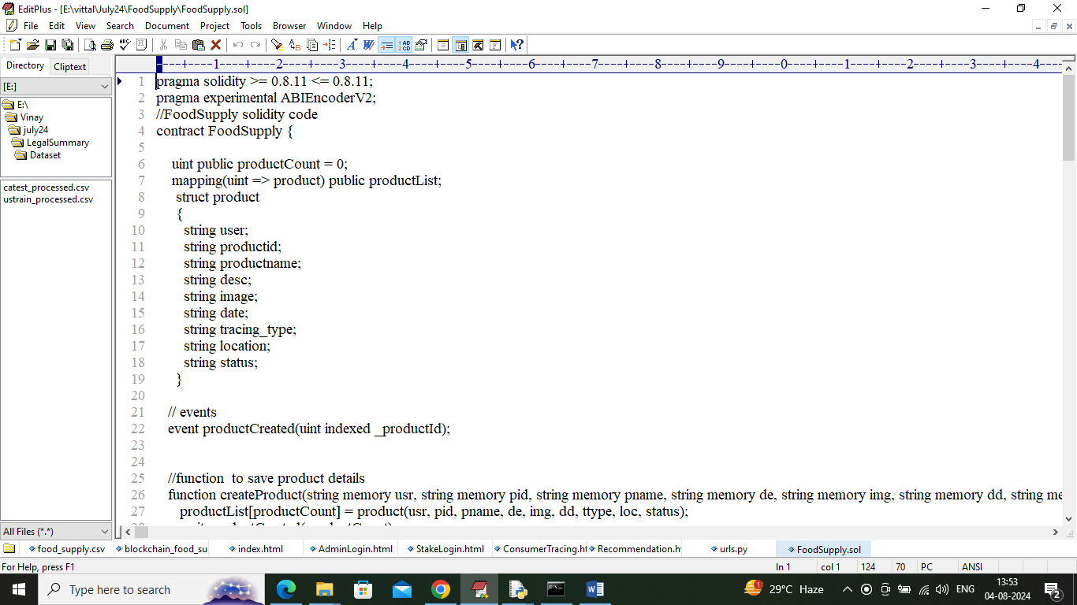

In above contract we have defined functions to manage and trace all details of a product and now we need to deploy above contract in ETHEREUM Blockchain by using below steps

1. First go inside ‘hello-eth/node-modules/bin’ folder and then look for file called ‘runBlockchain.bat’ file and then double click on that file to get below screen
2. 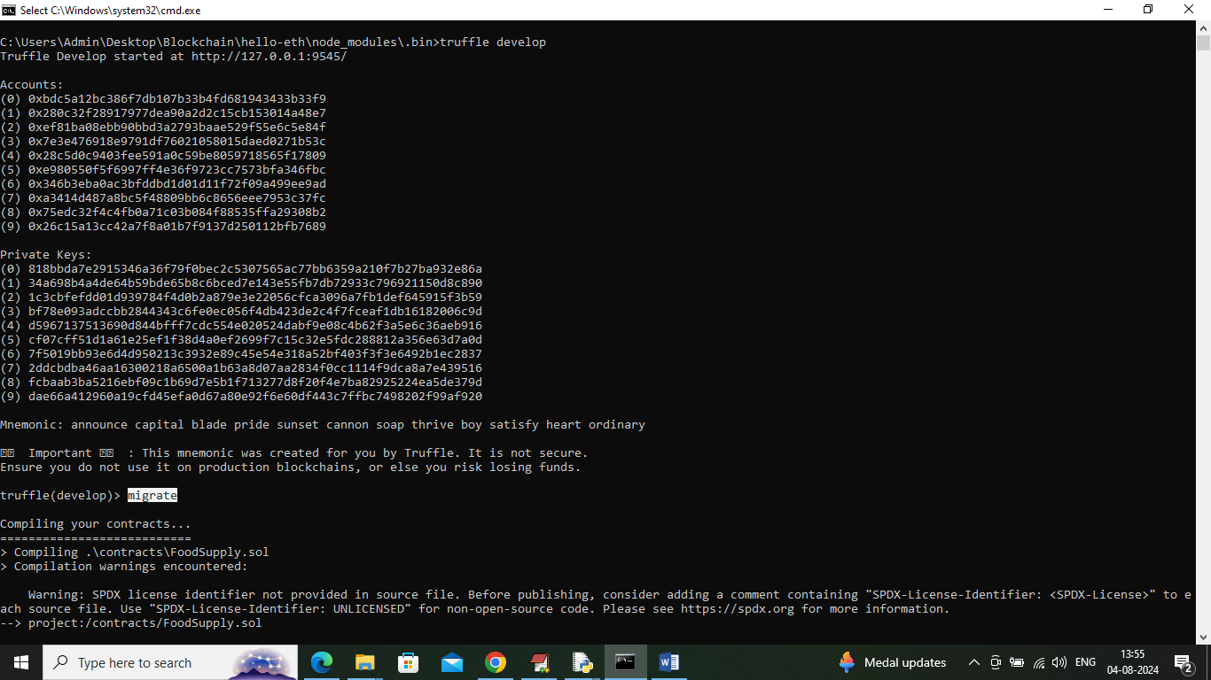
3. In above screen ETHEREUM started with default accounts and keys and now type command as ‘migrate’ and press enter key to get below page
4. 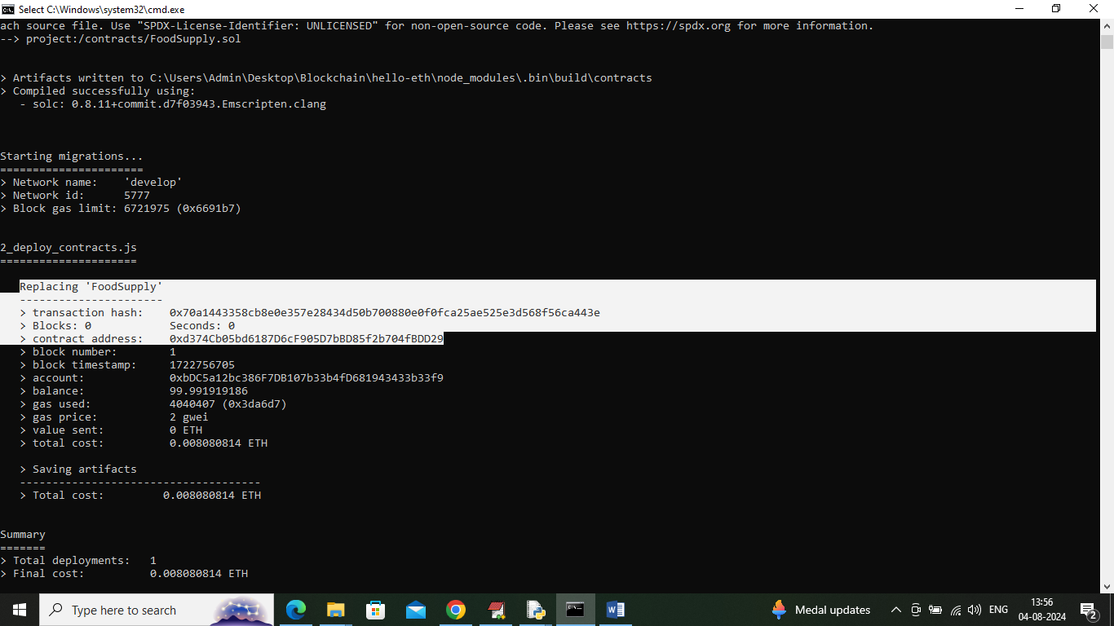
5. In above screen in white colour text can see ‘Food Supply’ contract deployed and got contract address also and this address need to specify in python code to call that contract. In above screen showing python code calling above contract using address
6. 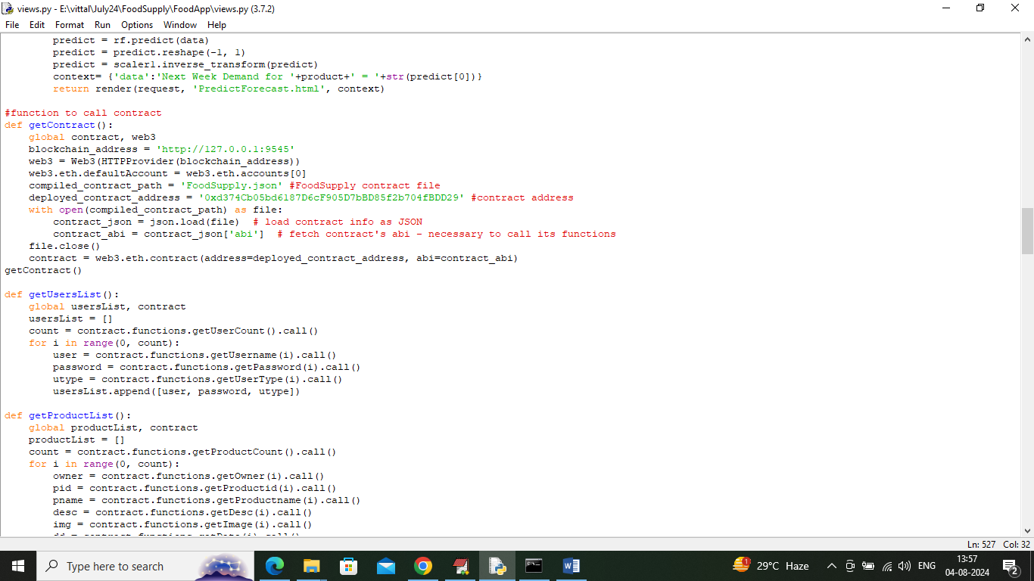
7. In above screen read red colour comments to know about contract calling and in above screens we have seen contract deployed and running and let that contract running. Now double click on ‘run.bat’ file to start python server and get below page
8. 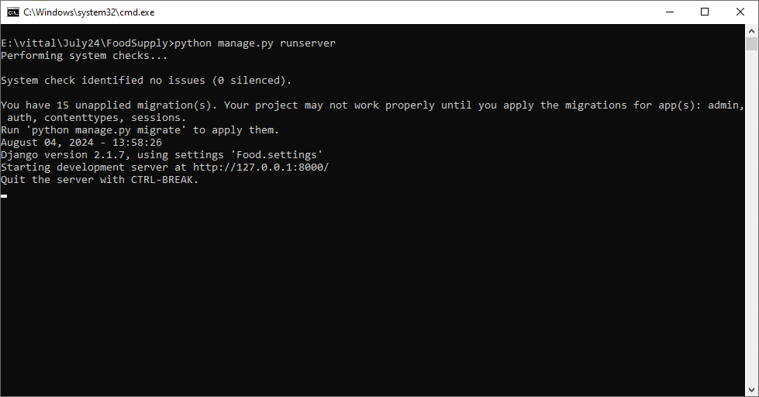
9. In above screen python server started and now open browser and enter URL as <http://127.0.0.1:8000/index.html> and press enter key to get below home page

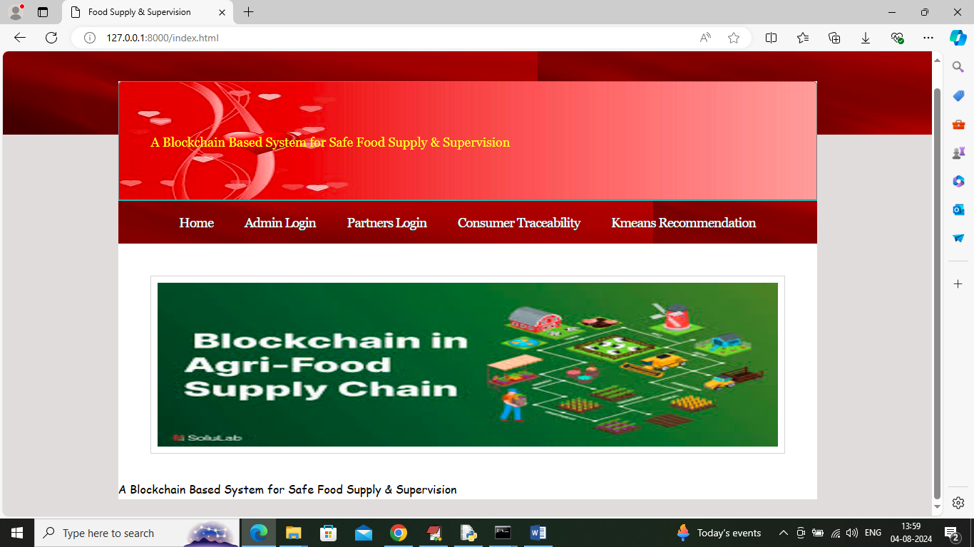

In above screen click on ‘Admin Login’ link to get below login page

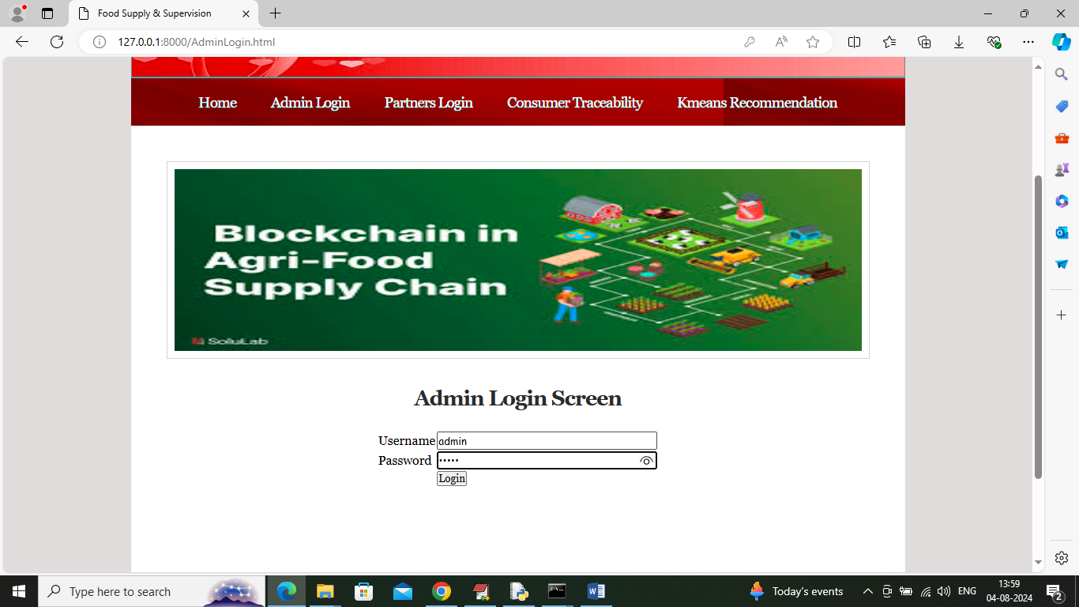

In above screen admin is login and after login will get below page

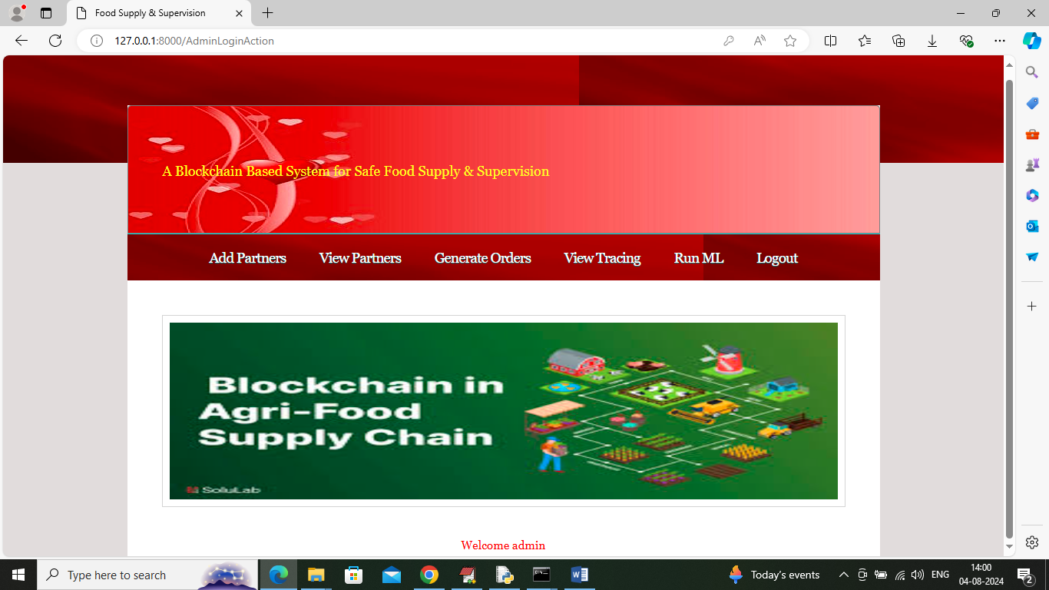

In above screen admin can click on ‘Add Partner’ link to get below page

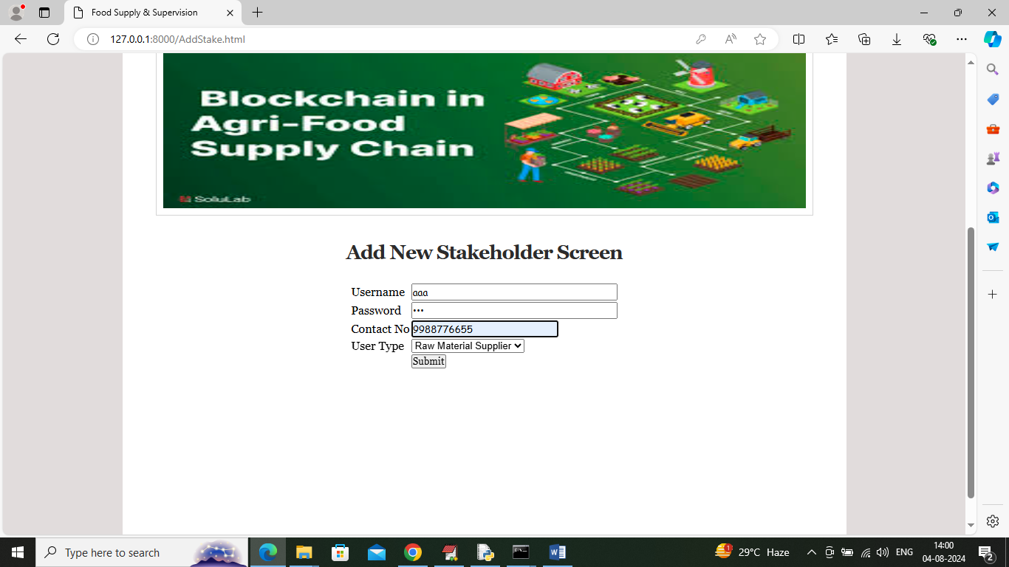

In above screen admin is adding details of ‘Raw Material’ partner and then click on button to save details in Blockchain and get below page

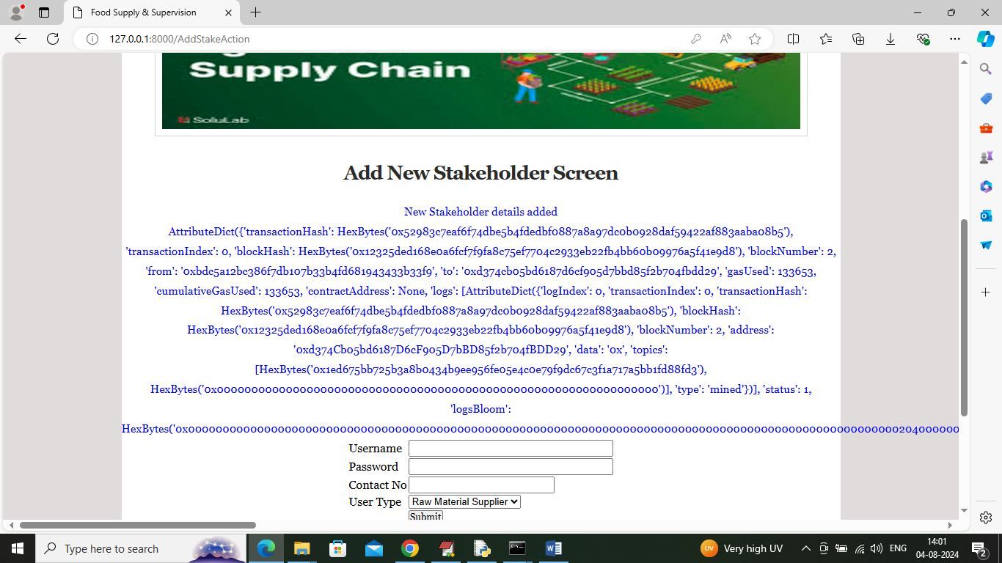

In above screen new stake holder or partner details added to Blockchain and for your guide and your understanding purpose I am displaying entire logs returned by Blockchain after storage. In above blue log can see Transaction no, block no, hash code and many other details. Similarly you can add other partner details like Manufacturer, retailer etc. Now admin can click on ‘View Partners’ link to view all partners’ details and get below page

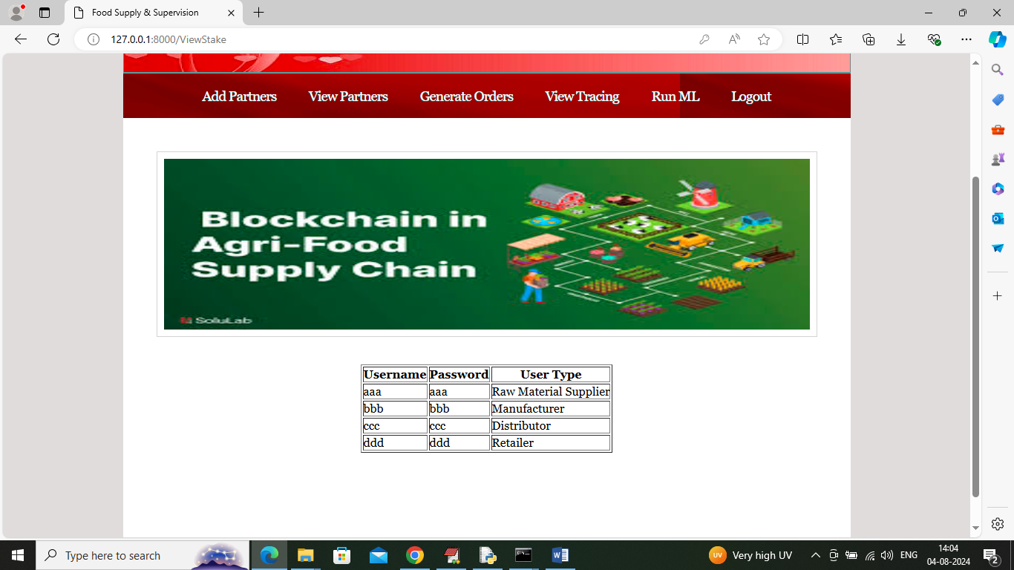

In above screen admin can view details of all added Partners and now click on ‘Generate Orders’ link to get below page

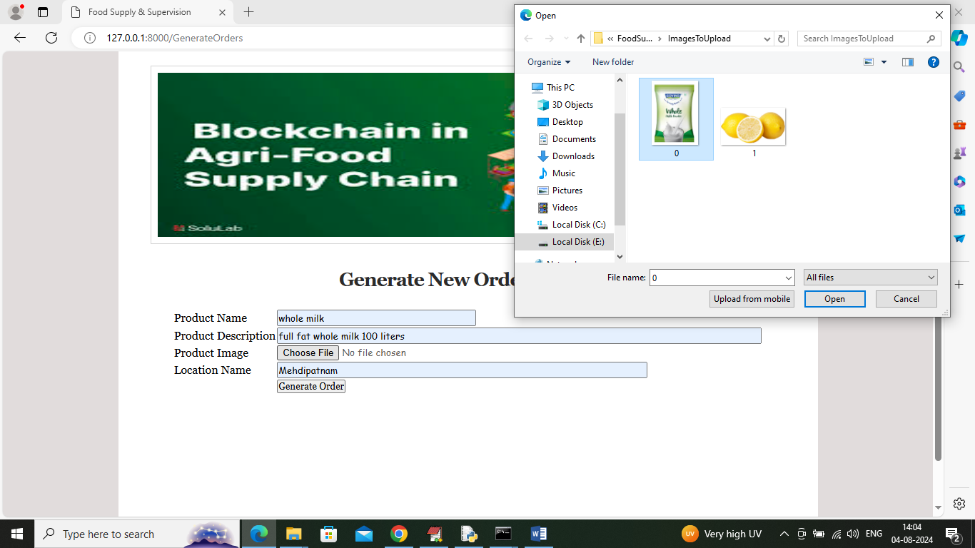

In above screen admin is generating order and adding order generated location so consumer can trace the location of each process of product (note: here we don’t have GPS in laptop so manually entering location). Admin will upload related product image and then press button to record order in Blockchain and get below page

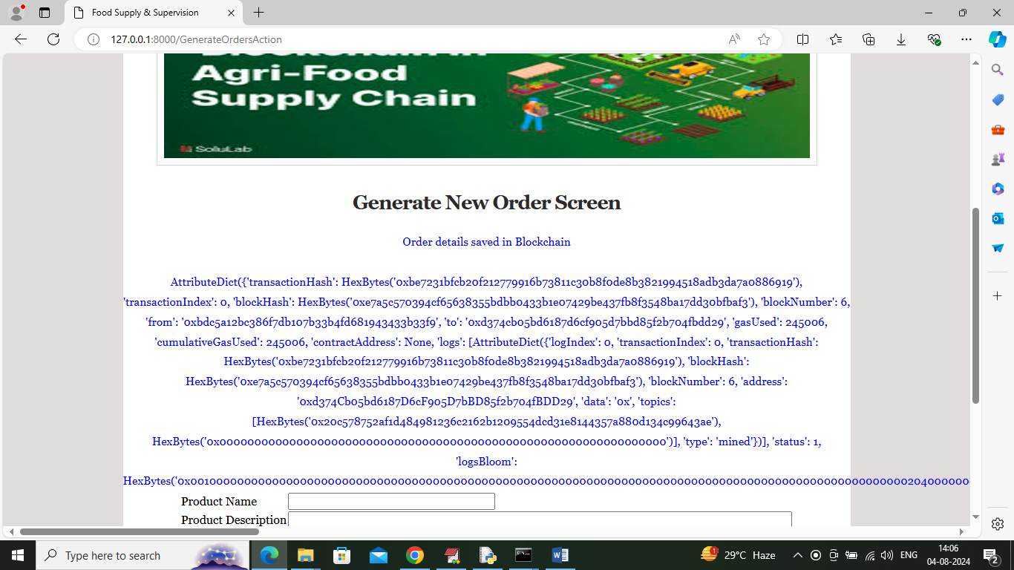

In above screen admin can see product order generated and can see all stored logs of Blockchain. Now click on ‘View Tracing’ link to get below page

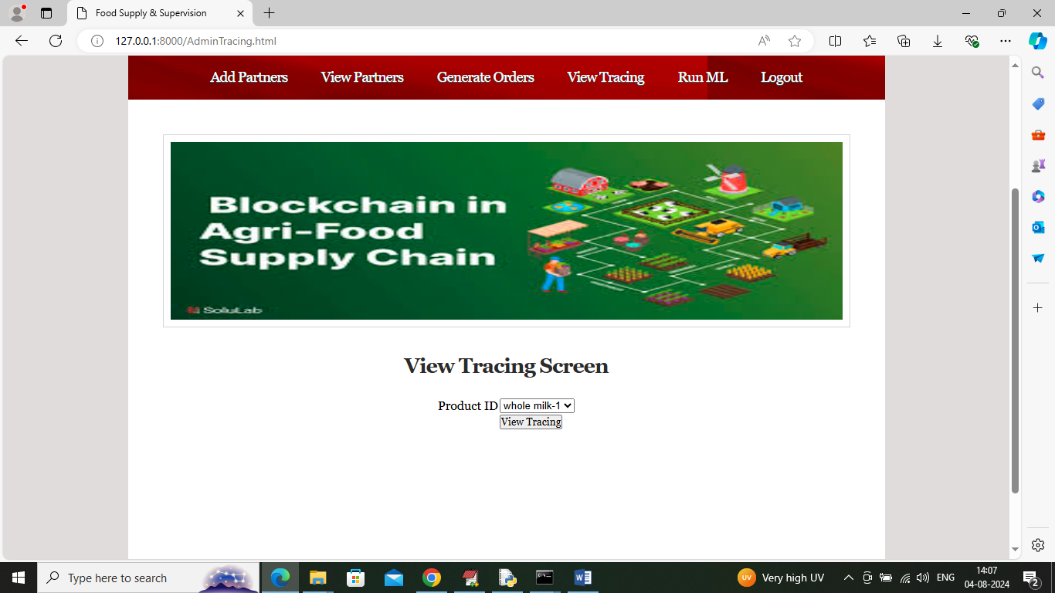

In above screen admin will select desired product ID and then press button to get below page

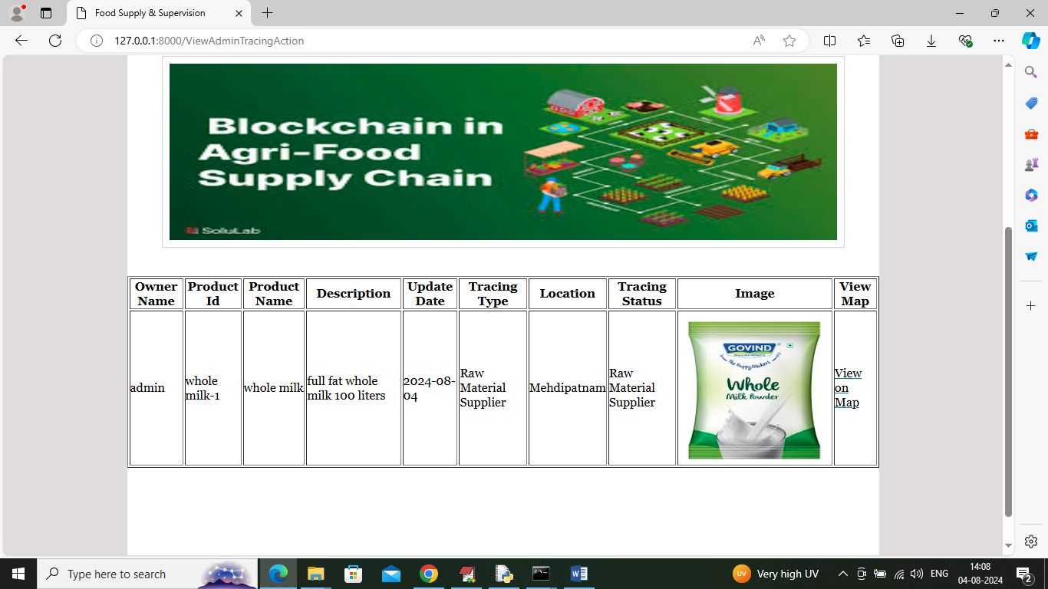

In above screen admin will see the tracing of order which went to Raw Material Supplier who will login and receive order to further process and admin can click on ‘View on Map’ link to view generated order location in map like below page (this you can consider as enhancement)

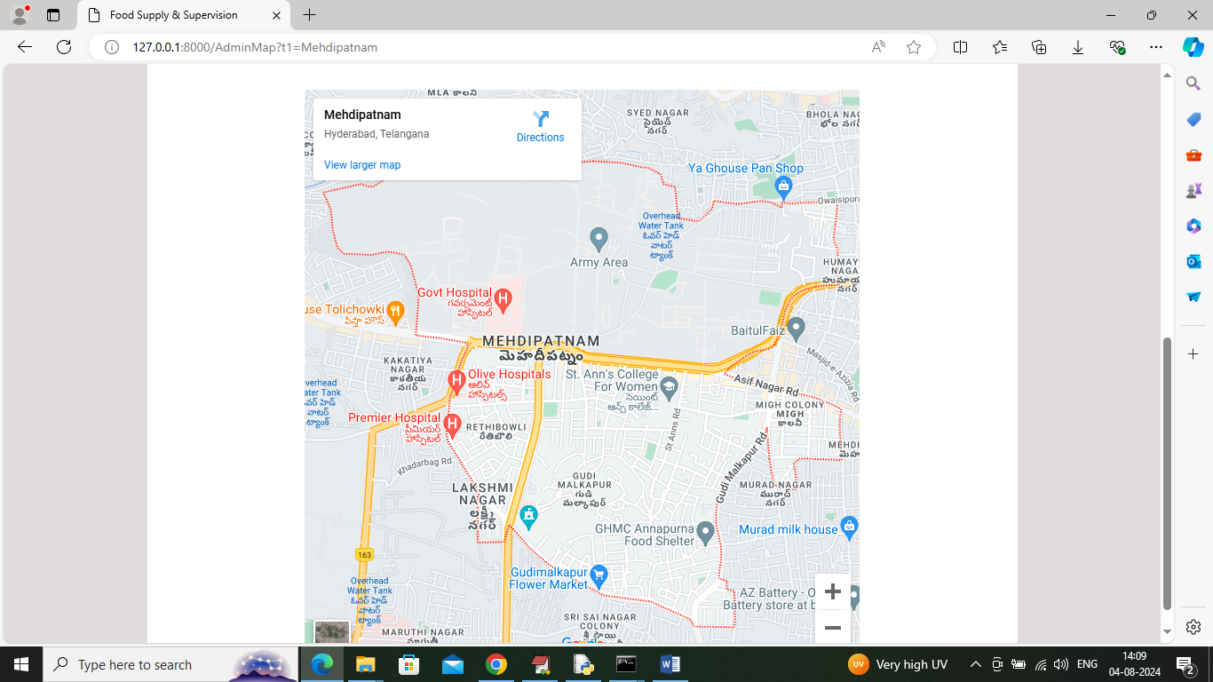

In above screen can see order generated location MAP and now admin can click on ‘Run ML’ link to get below page.

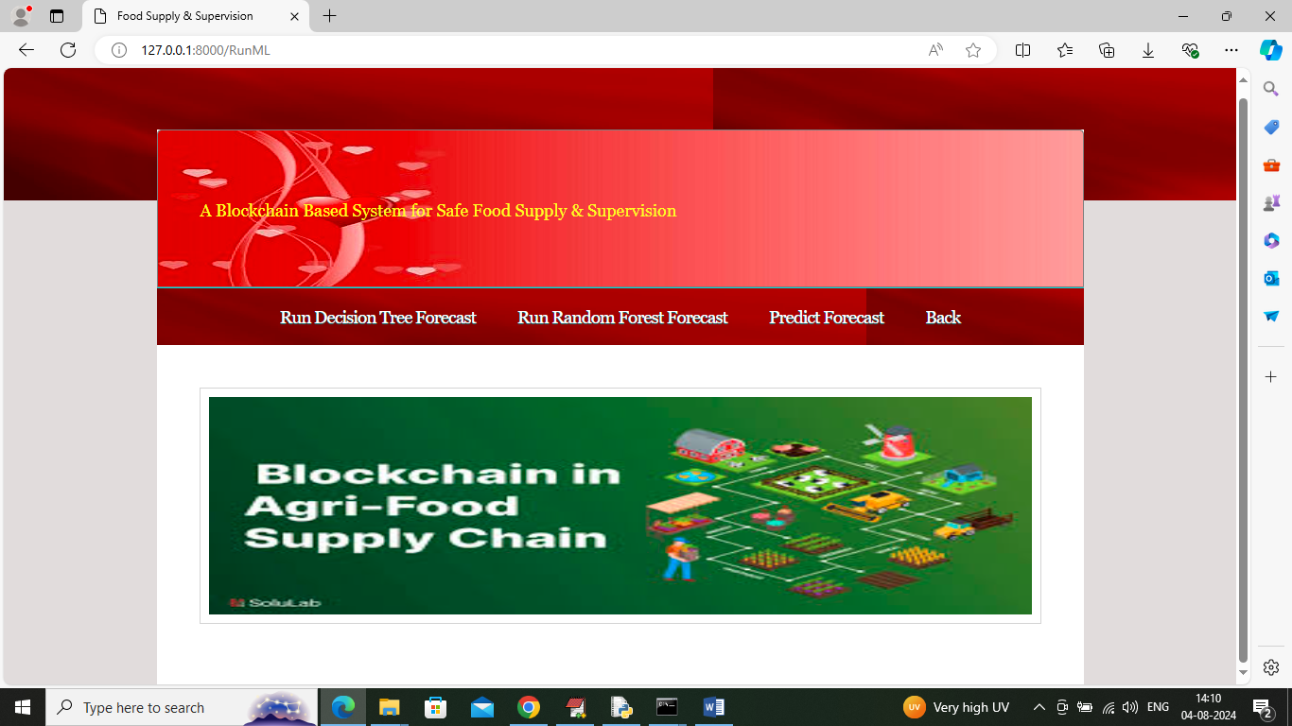

In above screen admin can click on ‘Run Decision Tree’ link to train Decision tree on dataset to forecast product demand and get below page

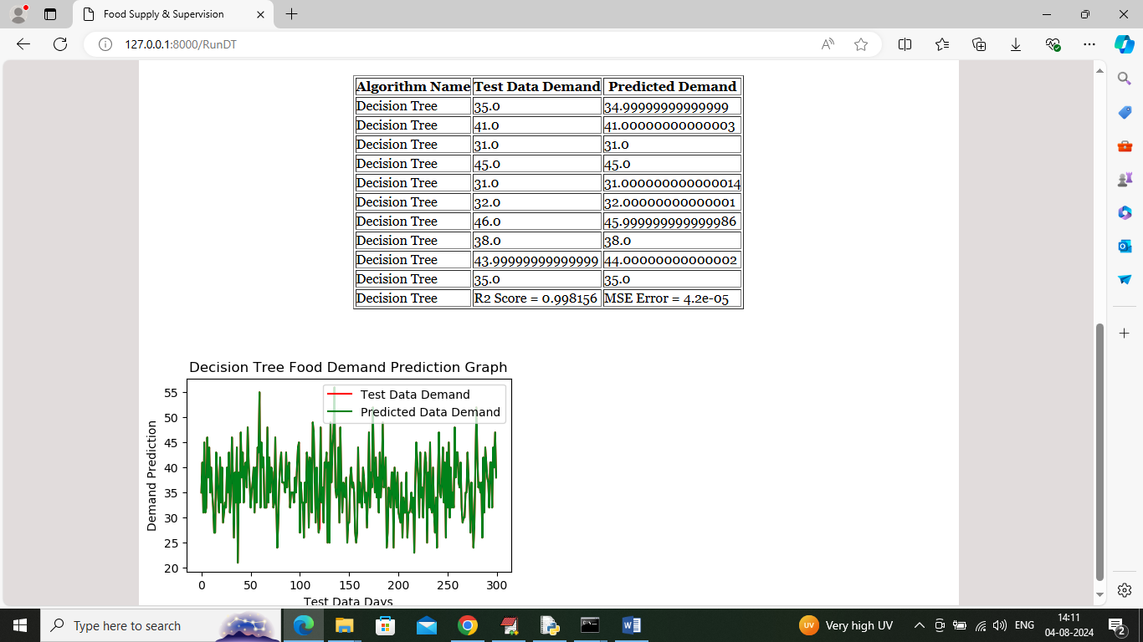

In above screen can see forecast result of decision tree where tabular output contains forecast of next 10 days and in that table we are showing algorithm name along with TEST data demand and predicted demand and can see both test and predicted values are very closed and in last row can see Decision Tree R2 Score as 99% and can see MSE error also. In graph x-axis represents number of days and y-axis represents forecast values and then red line represents TEST data demand value and green line represents Predicted demands and can see both lines are fully overlapping so we can say both test values and predicted values are accurate. Now click on ‘Run Random Forest’ link to train Random Forest and get below page

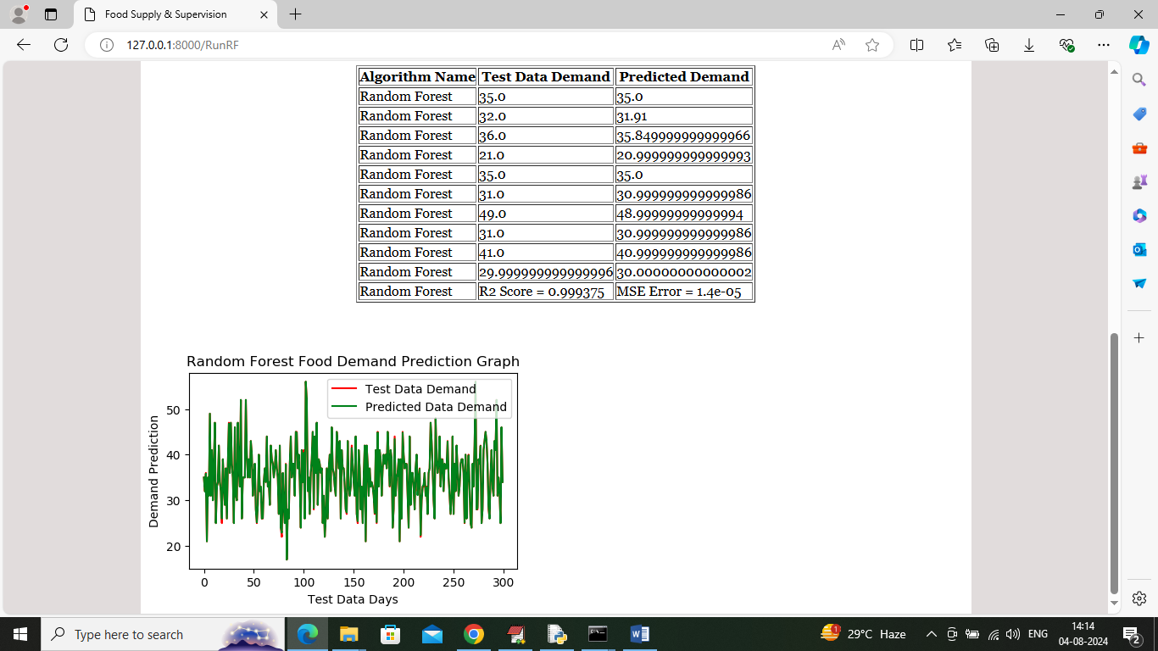

In above screen can see result or Random Forest algorithm and in last row can see R2Score which is slight higher than Decision tree and can say Random Forest is better than Decision tree and now click on ‘Predict Forecast’ link to get below page

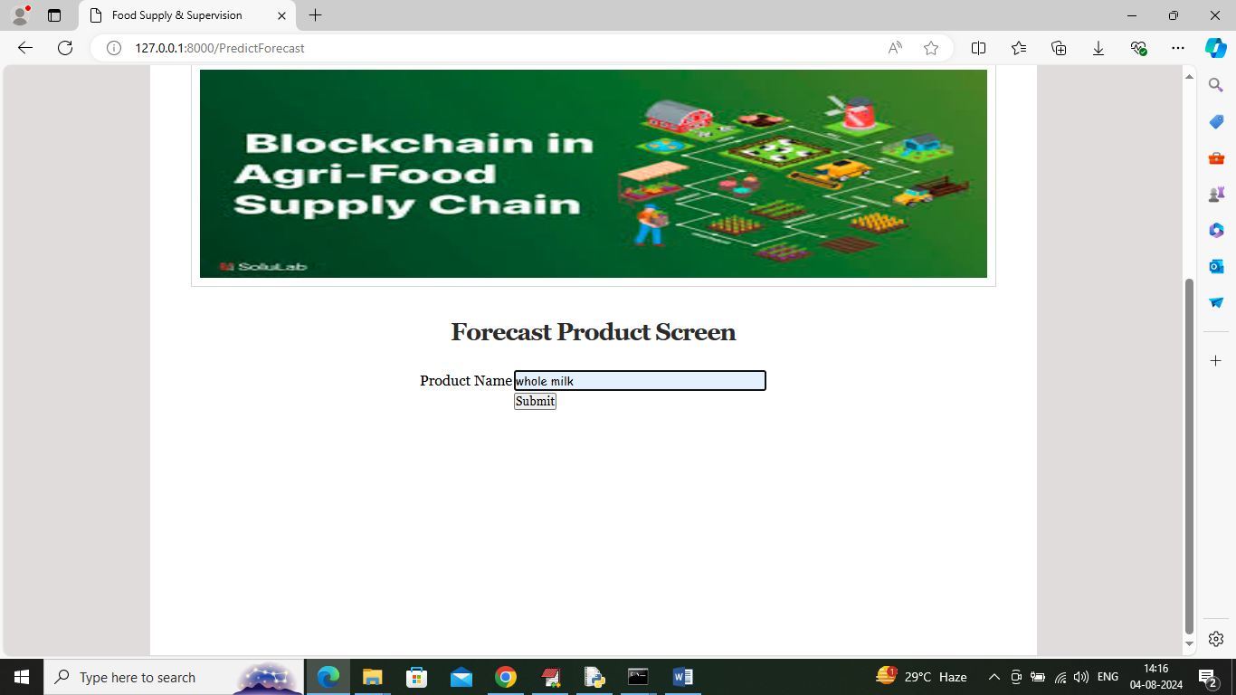

In above screen user will enter some product name and then will get below forecast

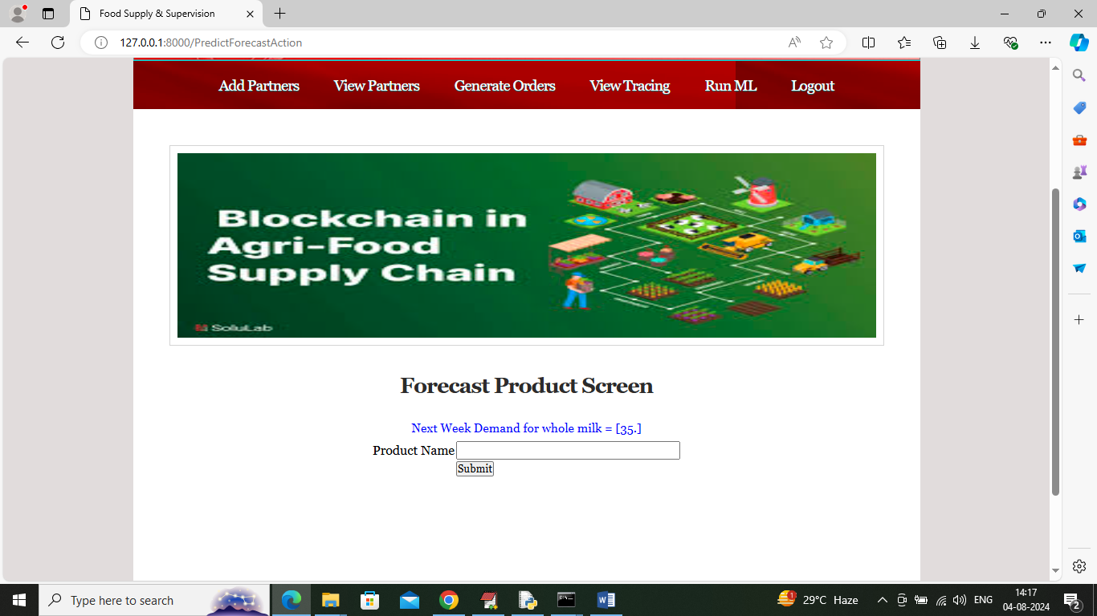

In above screen in blue colour text can see next day prediction is 35 litres and similarly enter any product details and get below output

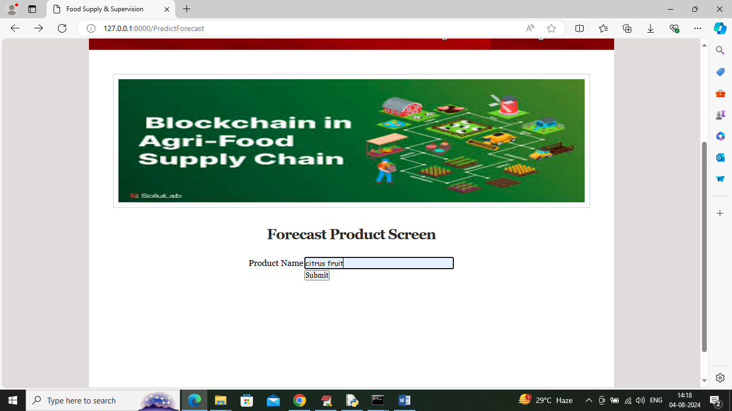

In above screen entering product name as ‘Citrus Fruit’ and below is the forecast output

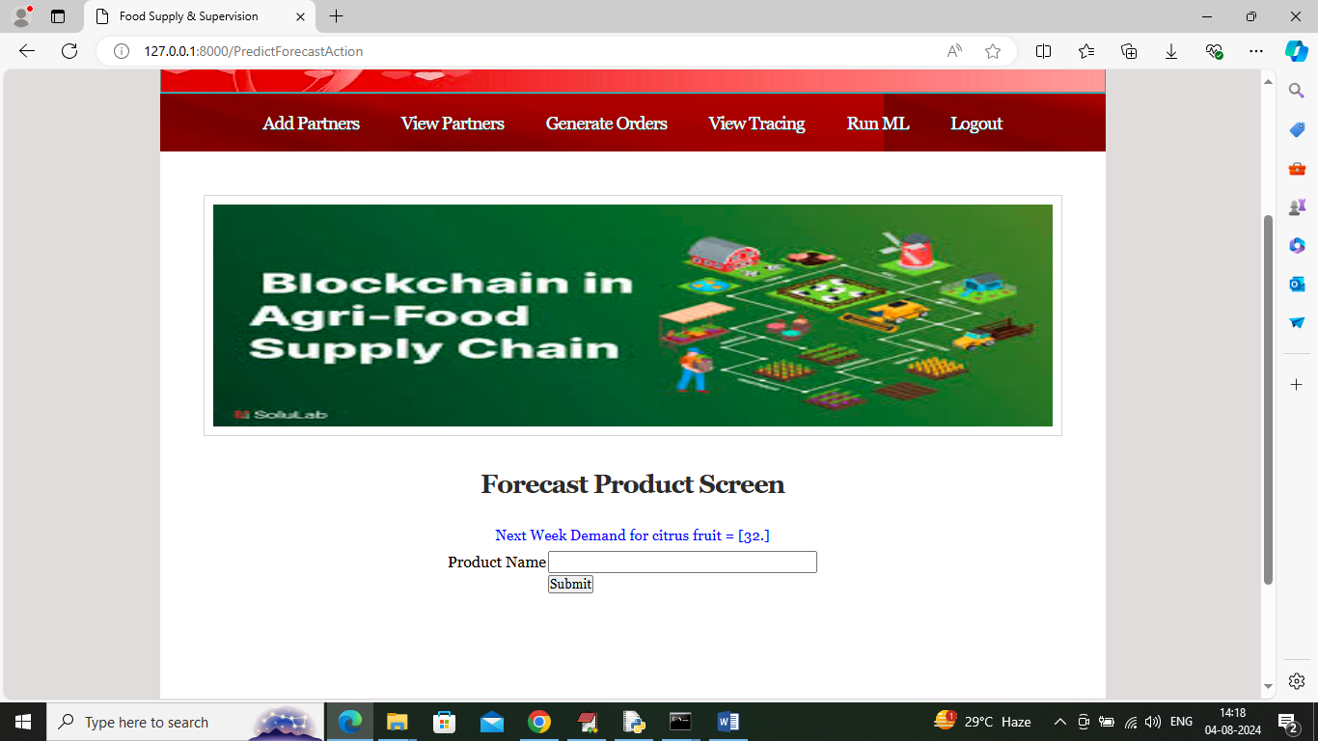

In above screen citrus fruit next day demand is 32 pieces. To train above algorithms and to know about product names you can see dataset file available inside ‘dataset’ folder. This dataset showing in below screen

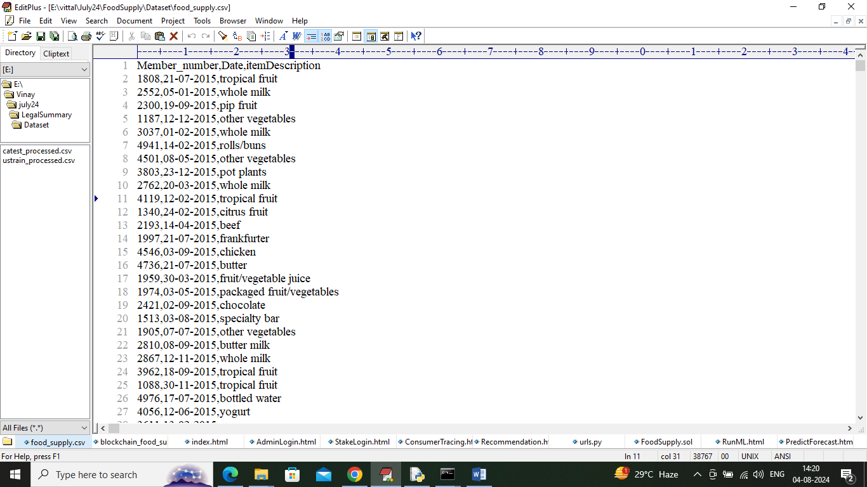

In above dataset screen whatever product names you are seeing you can input to application for forecast. Now logout and login as various partners for further product order processing

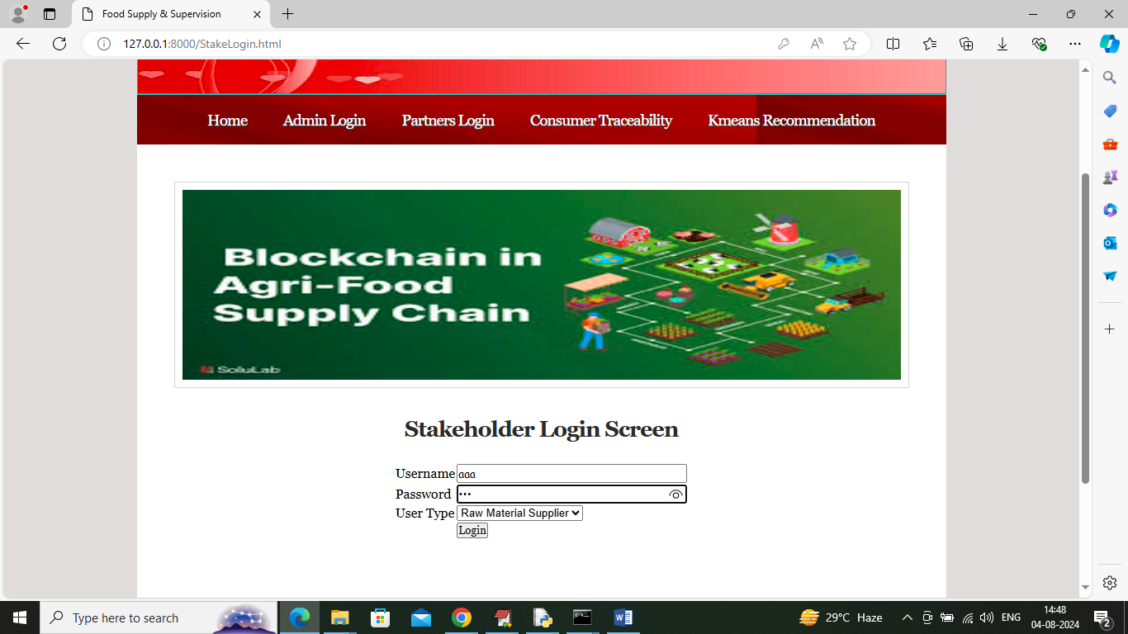

In above screen click on ‘Partners Login’ and then login as Raw material supplier to get below page

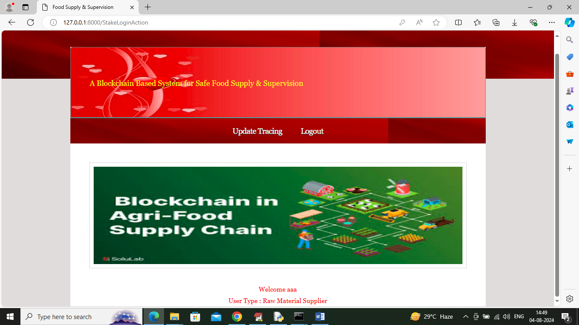

In above screen Raw Material supplier can click on ‘Update Tracing’ link to get below page

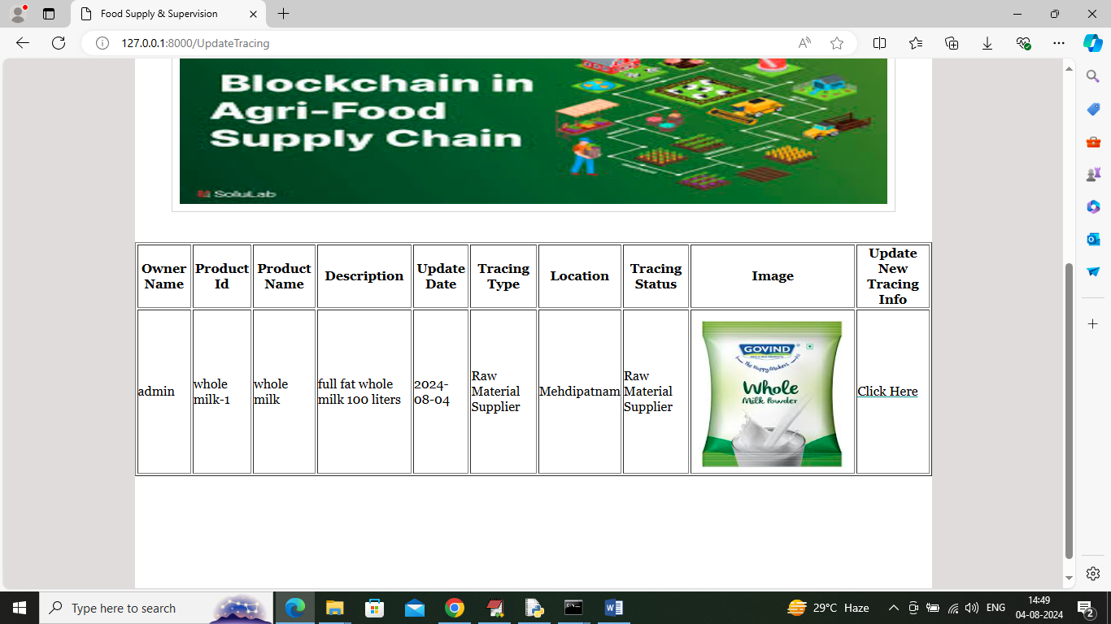

In above screen raw material supplier can click view receive order details and then click on ‘Click Here’ link to supply raw material to manufacturer

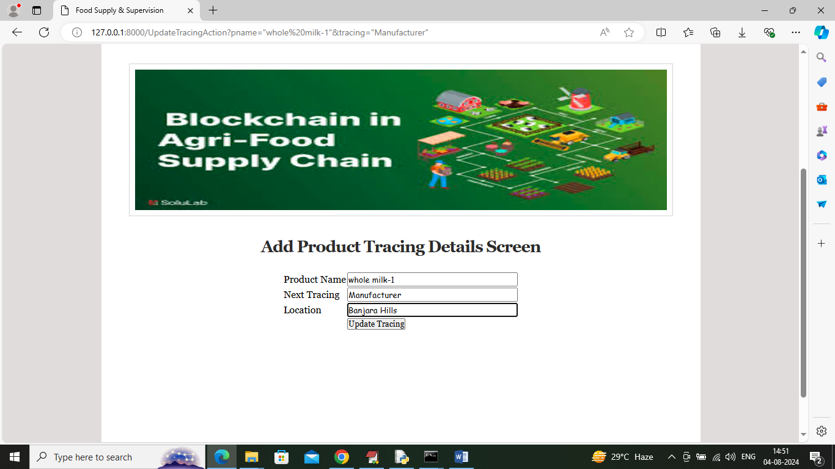

In above screen raw material supplier updating trace to Manufacturer and then Click on ‘Update Tracing’ button to record trace in Blockchain and get below page

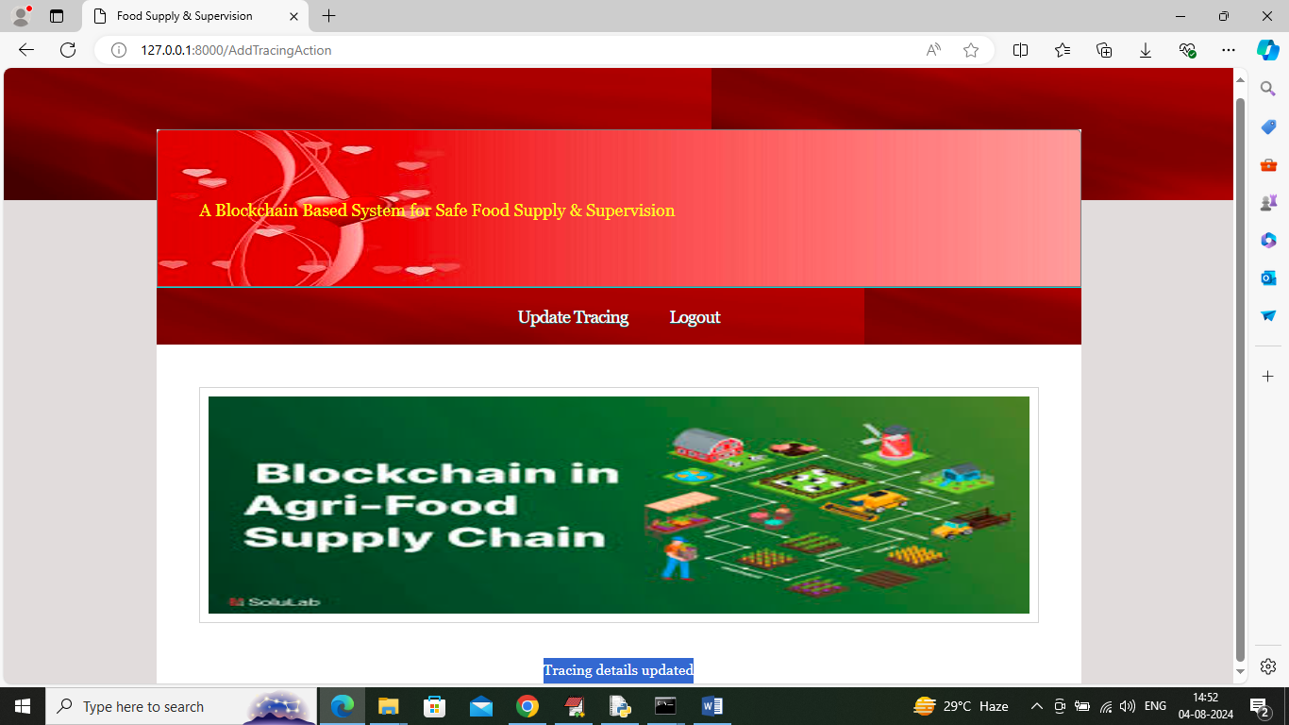

In above screen tracing details updated and now logout and login as ‘Manufacturer’ to manufacture order and to process further

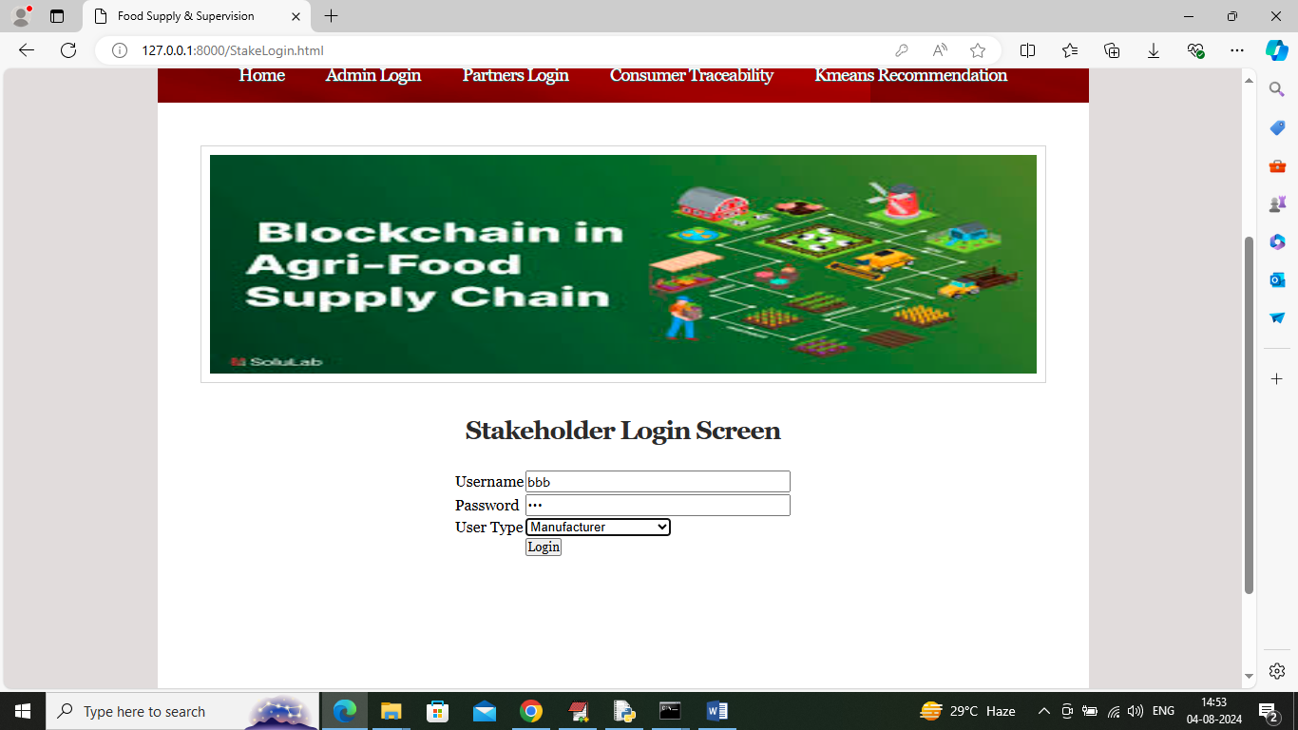

In above screen manufacturer is login and after login will get below page

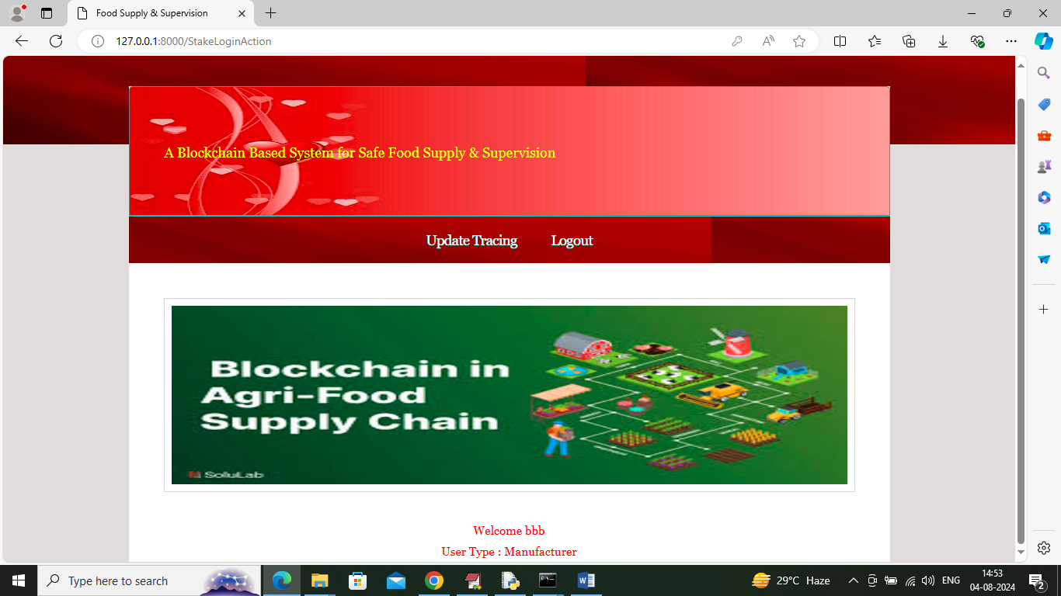

In above screen manufacturer will manufacture product and then update trace in below screen by clicking on ‘Update Tracing’

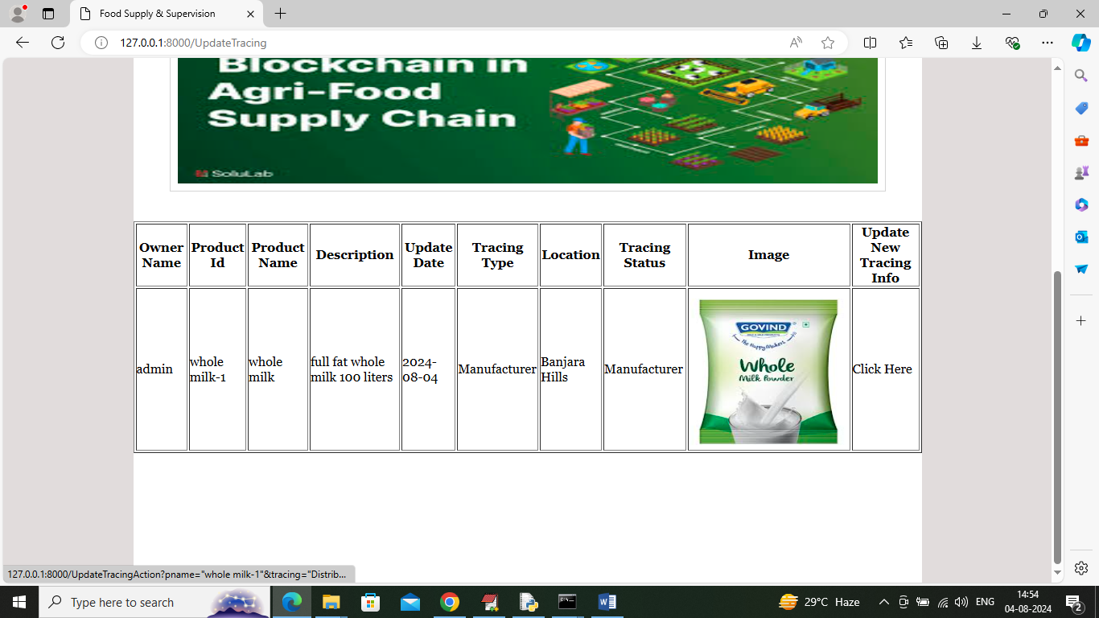

In above screen click on ‘Click Here’ link to update further process

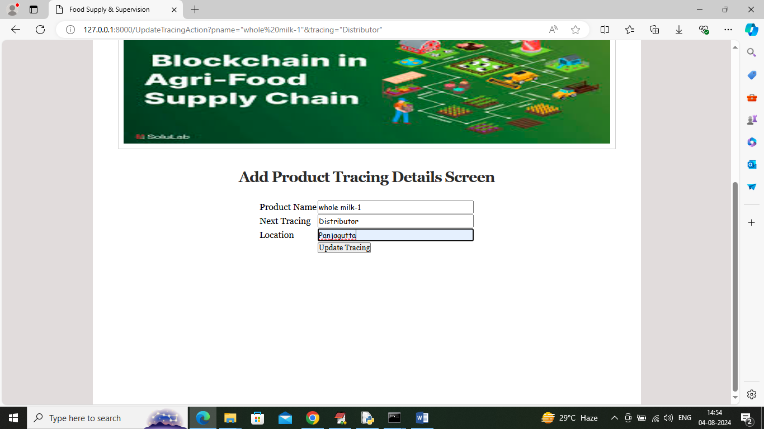

In above screen manufacturer is updating product trace to distributor after completing manufacturing and now logout and login as ‘Distributor’ to get below page

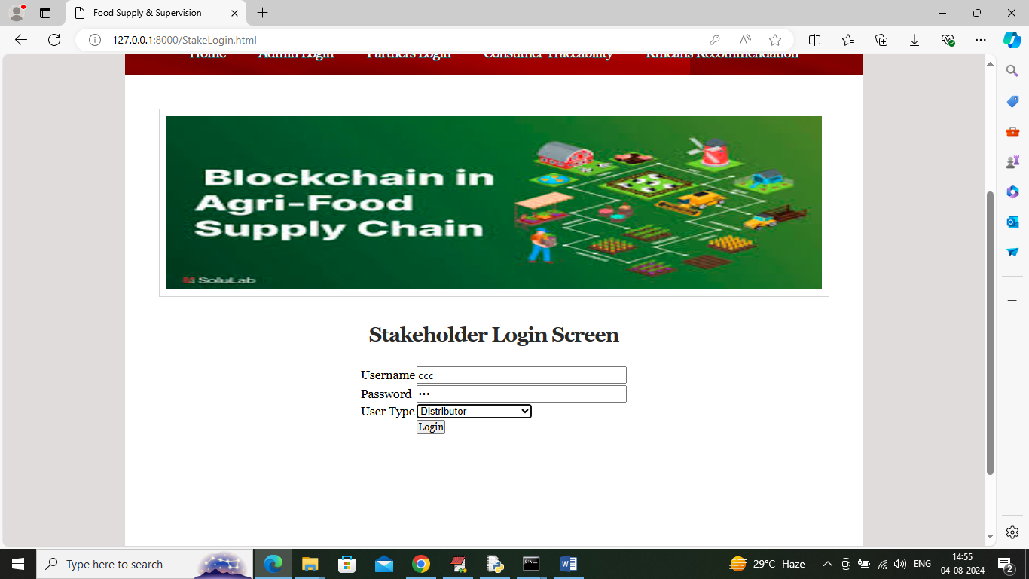

In above screen distributor is login and after login will get below page

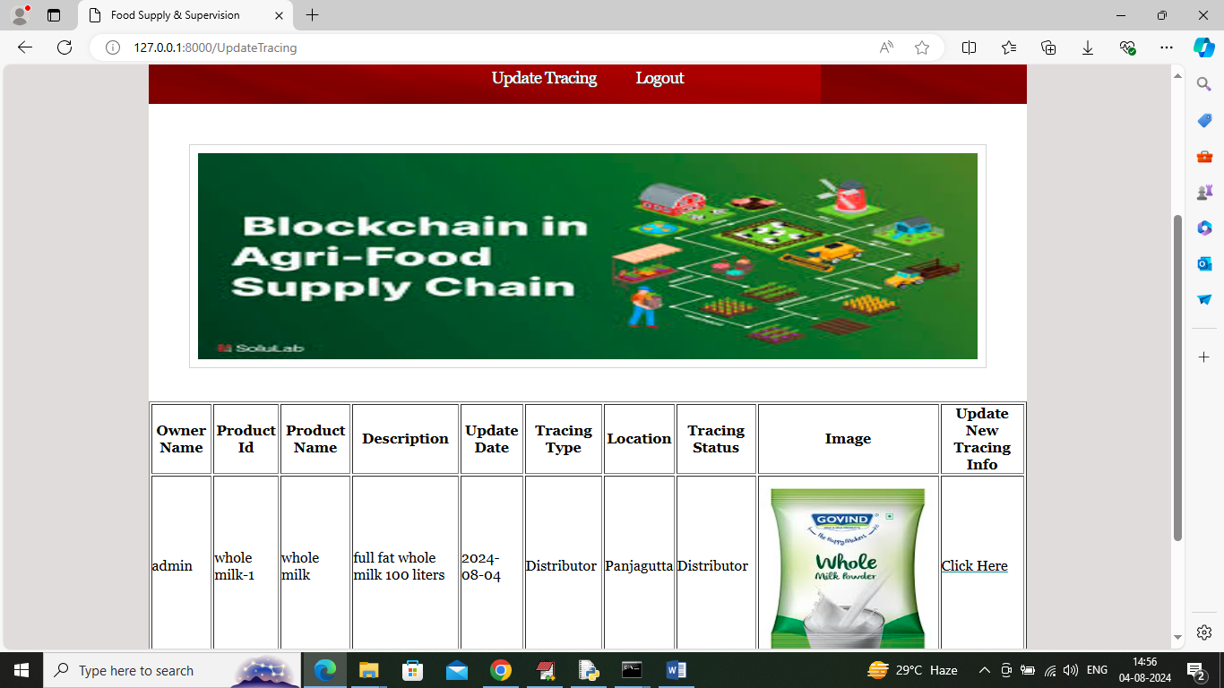

In above screen distributor can click on ‘Click Here’ link to update trace to retailer

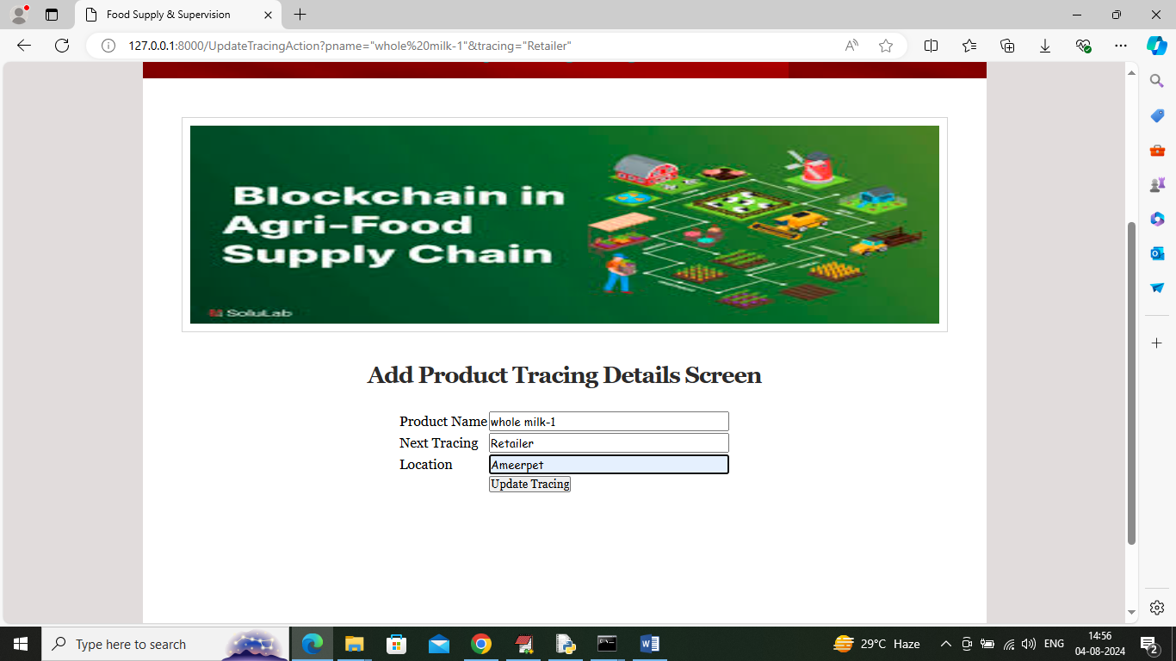

In above screen distributor sending order to Retailer and now logout and login as ‘retailer’ to sale to consumer

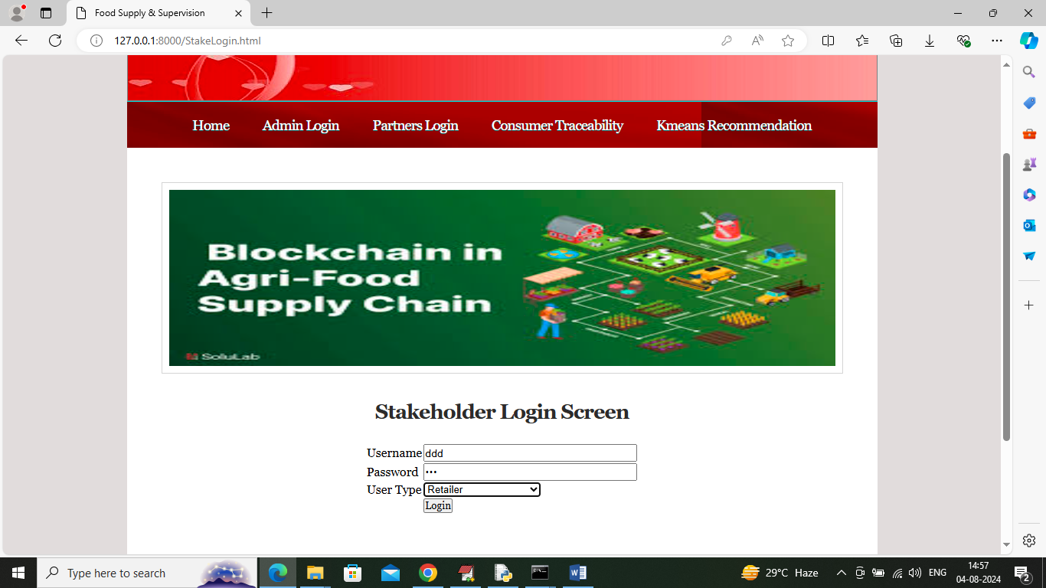

In above screen retailer is login and after login will get below page

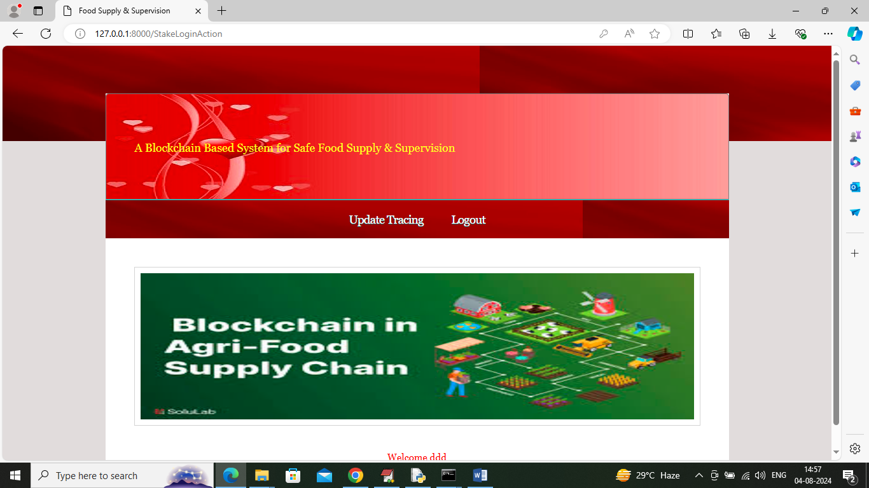

In above screen click on ‘Update Tracing’ link to get below page

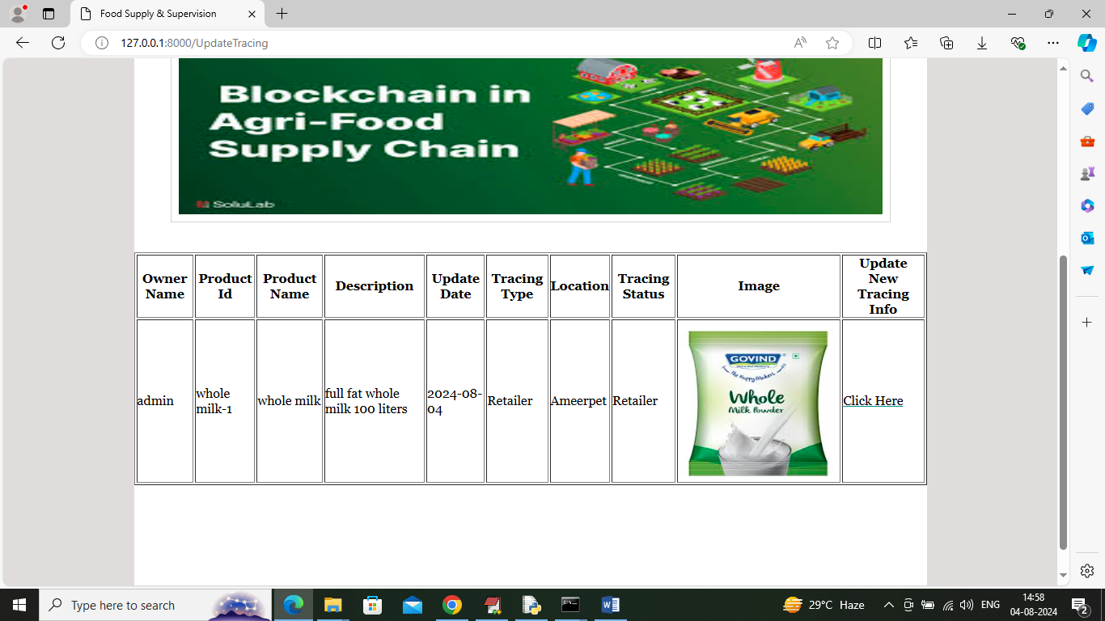

In above screen Retailer can click on ‘Click Here’ link to sale products to N consumer and get below page

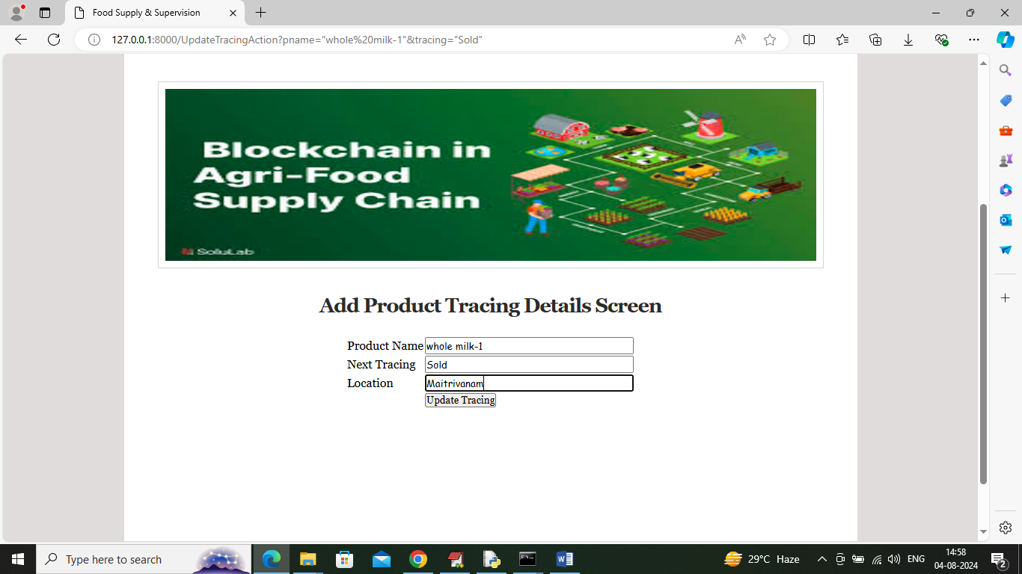

In above screen retailer is selling product to N consumer and by using this process each and every tracing details can be tracked and logout to get below page

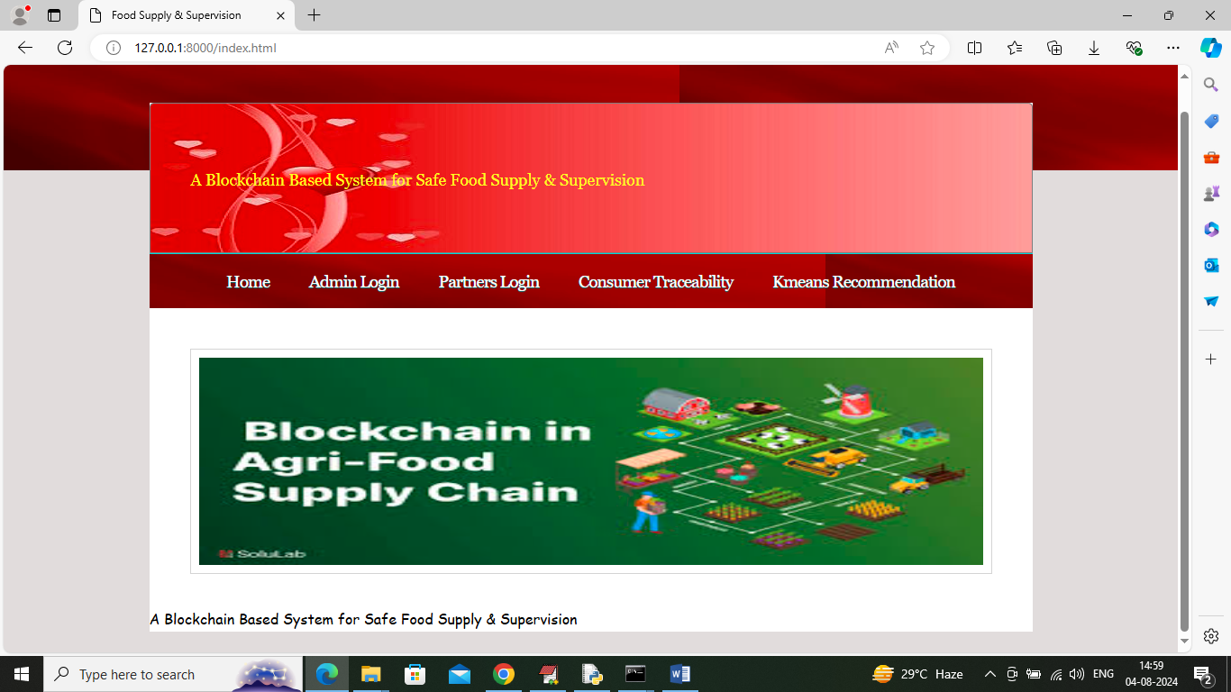

In above screen click on ‘Consumer Traceability’ link to get below page

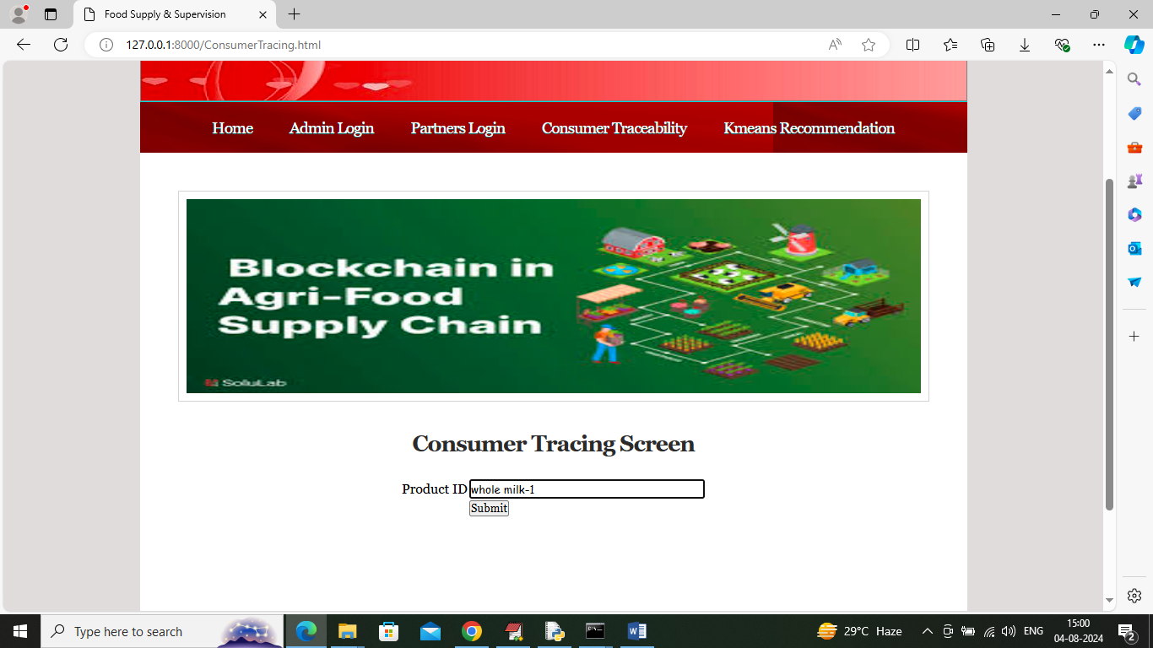

In above screen consumer will enter product ID of receive product and then press button to get below page

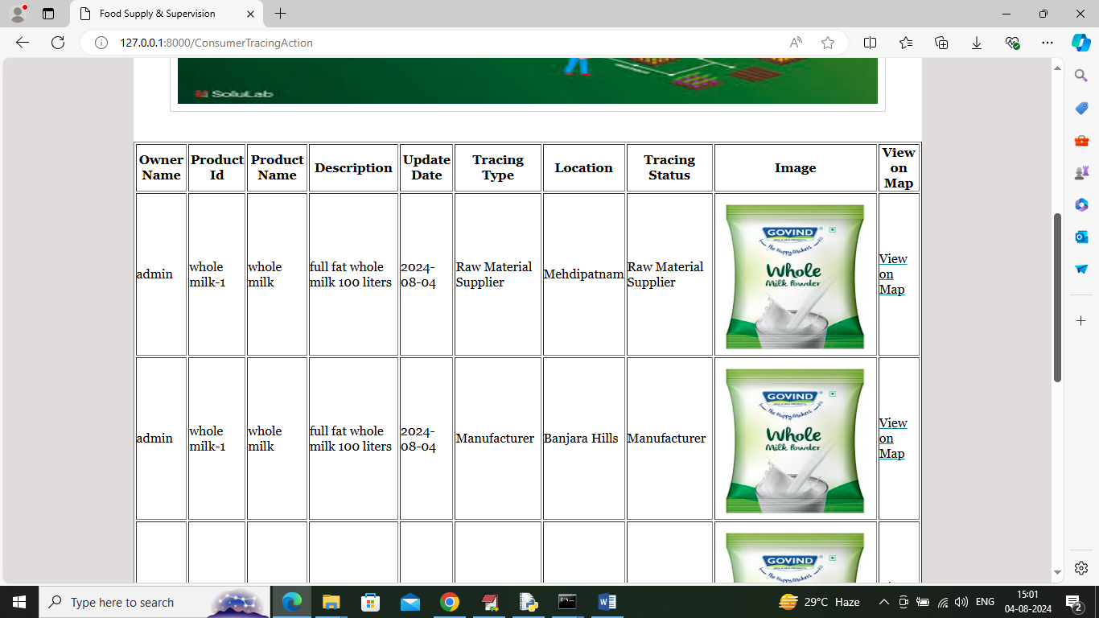

In above screen consumer can view or trace all stages of product processed and can click on ‘View Map’ link to view all trace location to map

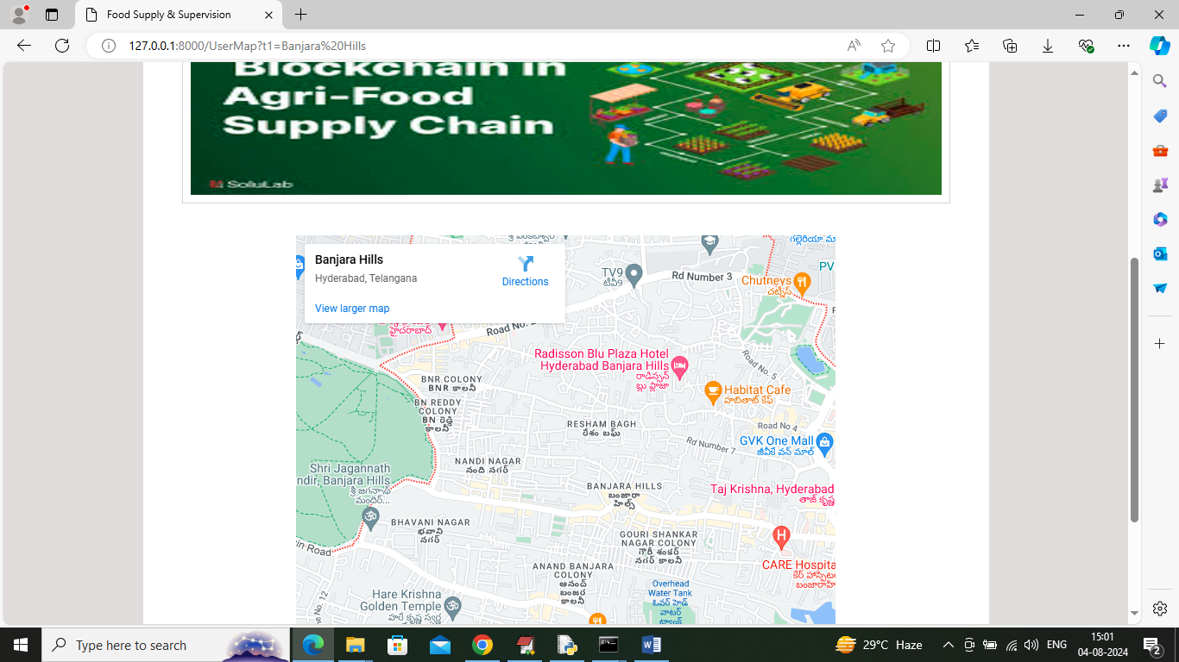

In above screen can see location map and now click on ‘KMEANS recommendation’ link to get below page

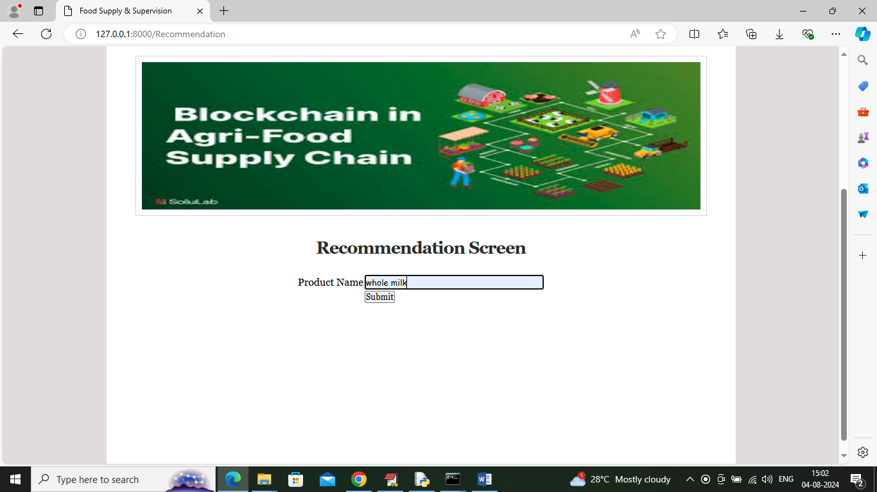

In above screen user is entering product name and then press button to get KMEANS based recommendation

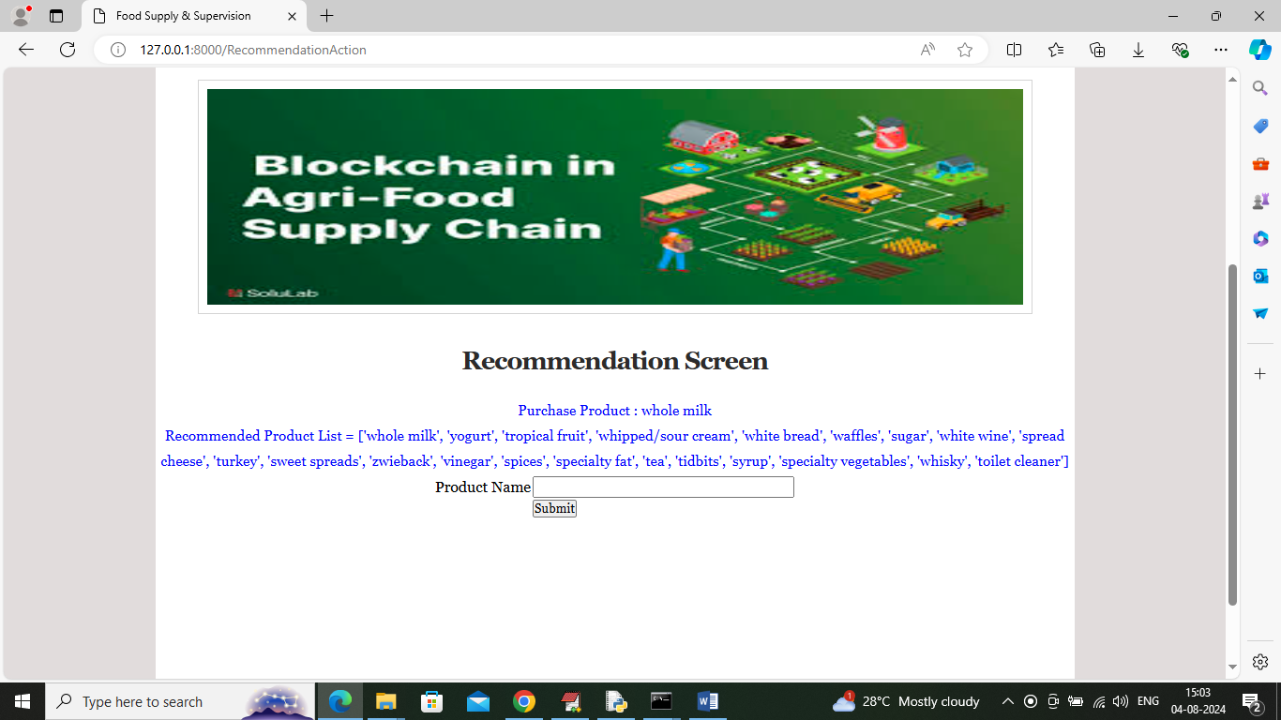

In above screen in blue colour text can see list or similar products as recommendation

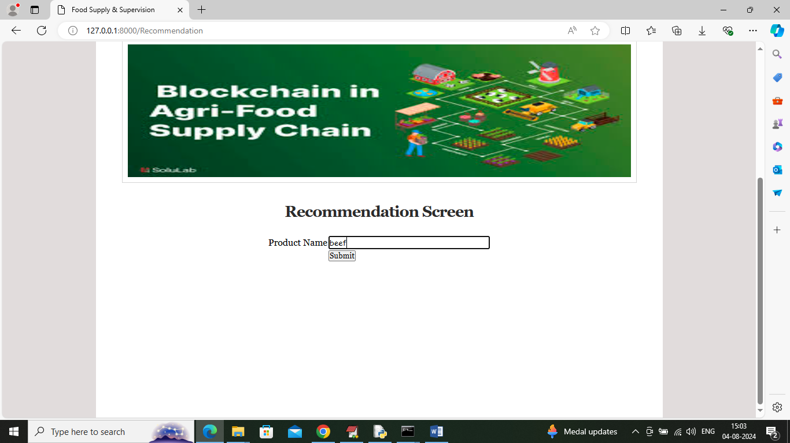

In above screen entering name as beef and below is the recommended output

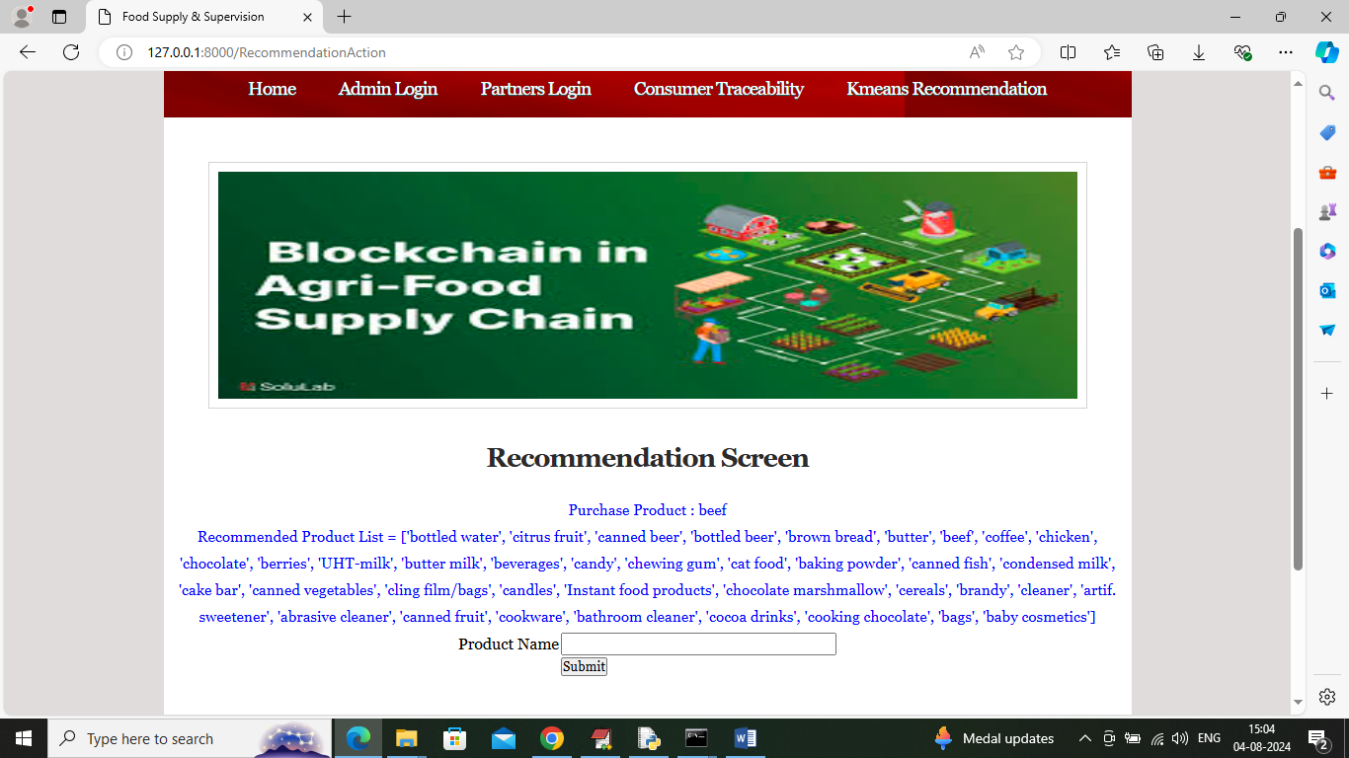

In above screen can see recommended list for ‘Beef’.

So by using above screens you can run project to trace product details, forecast and recommend items.

**8. CONCLUSION:**

This article proposed a generic solution framework utilizing IoT technology and Ethereum blockchain-based smart contracts to track the food supply chain network directly, eliminating the requirement of a central validating authority. The paper presents the details on the functionality of a smart contract, the sequence diagrams that show the interactions between entities in the contract in a comprehensive manner, and finally, present some of the key aspects of the smart contract in form of algorithms. The solution presented in this article focuses on poultry products and meat (both fresh and frozen). But this solution is comprehensive enough to be extended for food supply chain traceability and tractability of any kind of food product while in the supply chain network which comprises multiple entities. The solution aims to prevent poor quality and deteriorated food products from reaching the consumers thereby protecting consumer rights, increased legal culpability as well as improving the overall brand image of the food product. As a part of future work, we aim to develop a multi-tier infrastructure with supply chain participants and stakeholders over a Hyperledger framework. This paper proposes applying AI and big data capabilities to uncover new knowledge that decision-makers can use to make optimal decisions within the supply chain processes. Machine learning algorithms using large volumes of data coming from IoT sensors can be used to mine patterns in supply chain data and forecast future demands thereby reducing wastage of food products. This can also assist in the identification and mitigation of transportation-related risks, thereby increasing visibility and trust among food processing & packaging companies, distributors, and retailers.

**9. REFERENCES:**

1. Van Boxstael S, Habib I, Jacxsens L, De Vocht M, Baert L, Van de Perre E, Rajkovic A, Lopez-Galvez F, Sampers I, Spanoghe P, De Meulenaer B (2013) Food safety issues in fresh produce: bacterial pathogens, viruses and pesticide residues indicated as major concerns by stakeholders in the fresh produce chain. Food Control 32(1):190– 197

2. Johnson R (2014) Food fraud and economically motivated adulteration of food and food ingredients. Congressional Research Service. http://www.fredsakademiet.dk/ORDBOG/lord/food_fraud.pdf. Accessed 23 July 2020

3. Calvin L, Gale Jr, HF, Hu D, Lohmar B (2006) Food safety improvements underway in China, No. 1490–2016-127765, pp. 16–21

4. Everstine K, Spink J, Kennedy S (2013) Economically motivated adulteration (EMA) of food: common characteristics of EMA incidents. J Food Prot 76(4):723–735

5. World Health Organization (1993) Contaminated food: a major cause of diarrhea and associated malnutrition among infants and young children. Facts about infant feeding. 3:1–4

6. Scallan E, Hoekstra RM, Angulo FJ, Tauxe RV, Widdowson MA, Roy SL, Jones JL, Griffin PM (2011) Foodborne illness acquired in the United States—major pathogens. Emerg Infect Dis 17(1):7–15

7. Chebolu-Subramanian V, Gaukler GM (2015) Product contamination in a multi-stage food supply chain. Eur J Oper Res 244(1):164– 175

8. Collier MG, Khudyakov YE, Selvage D, Adams-Cameron M, Epson E, Cronquist A, Jervis RH, Lamba K, Kimura AC, Sowadsky R, Hassan R (2014) Outbreak of hepatitis A in the USA associated with frozen pomegranate arils imported from Turkey: an epidemiological case study. Lancet Infect Diseas 14(10):976–981

9. Nukala R, Panduru K, Shields A, Riordan D, Doody P, Walsh J (2016) Internet of Things: A review from ‘Farm to Fork’. IEEE: In 2016, 27th Irish signals and systems conference (ISSC). Londonderry, 1-6 DOI: https://doi.org/10.1109/ISSC.2016.7528456

10. Estévez M (2015) Oxidative damage to poultry: from farm to fork. Poult Sci 94(6):1368–1378

11. da Silva MV (2013) Poultry and poultry products-risks for human health. Food and Agriculture Organization of the United Nations. Poultry Development Review. https://pdfs.semanticscholar.org/ bd59/8d369dd05bb6ac4d11ab8ec155b5b93e8a53.pdf. Accessed 23 July 2020

12. Butcher T, Grant DB (2012) Identifying supply chain value using RFID-enabled distributed decision-making for food quality and assurance. In: Chan H, Lettice F, Durowoju O (eds) Decision-making for supply chain integration. Springer, London, pp 89–103

13. Swan M (2015) Blockchain: blueprint for a new economy. O’Reilly Media, Inc, USA

14. Pilkington M (2016) Blockchain technology: principles and applications. In the Research handbook on digital transformations. Edward Elgar Publishing

15. Androulaki E, Barger A, Bortnikov V, Cachin C, Christidis K, De Caro A, Enyeart D, Ferris C, Laventman G, Manevich Y, Muralidharan S (2018) Hyperledger fabric: a distributed operating system for permissioned blockchains. In Proceedings of the Thirteenth EuroSys Conference 1-15 April

16. Tian F (2016) An agri-food supply chain traceability system for China based on RFID & blockchain technology. IEEE: In 2016 13th International conference on service systems and service management (ICSSSM). 1–6

17. Kamath R (2018) Food traceability on blockchain: Walmart’s pork and mango pilots with IBM. J British Blockchain Assoc 1(1):47–53

18. Yiannas F (2018) A new era of food transparency powered by blockchain. Innov Technol Gov Global 12(1–2):46–56

19. Lin Q, Wang H, Pei X, Wang J (2019) Food safety traceability system based on blockchain and EPCIS. IEEE Access. 7:20698– 20707

20. Abdel-Basset M, Manogaran G, Mohamed M (2018) Internet of things (IoT) and its impact on supply chain: a framework for building smart, secure, and efficient systems. Futur Gener Comput Syst 86:614–628